A-Level Physics transition



The Astley Cooper School

Name: ________________

Contents | Page
Understanding the specification and the assessments | 3-6
Transition activities 1-3 Scientific vocabulary | 8-10
Transition activity 4 SI units and prefixes | 12
Transition activity 5 Converting data | 12
Transition activity 6 Practical skills: investigating springs | 13-14
Transition activity 7 Using Greek letters | 15
Transition activity 8 Using the Physics formula and data sheet | 15
Transition activity 9 Using the delta symbol | 17
Transition activity 10 Rearranging formulas | 18
Transition activity 11 Standard form | 19
Transition activity 12 Significant figures and rounding | 20
Transition activity 13 Fractions, ratios and percentages | 21
Transition activity 14 Pythagoras’ theorem | 22
Transition activity 15 Using sine, cosine and tangent | 23
Transition activity 16 Arithmetic means | 23
Transition activity 17 Gradients and areas | 24-25
Transition activity 18 Using and interpreting data in tables and graphs | 25-32

Aim of the booklet
This booklet will support your transition from GCSE science to A-level. At first, you may find the jump in demand a little daunting, but if you follow the tips and advice in this guide, you’ll soon adapt. As you follow the course you will see how the skills and content you learnt at GCSE will be developed and your knowledge and understanding of all these elements will progress.
We have organised the guide into two sections:

- Understanding the specification and the assessments
- Transition activities to bridge the move from GCSE to the start of the A-level course.
Understanding the specification and the assessments
Specification at a glance

The specification is a useful reference document for you. You can download a copy from our website here.

The most relevant areas of the specification for students are the following:

Section 3: Subject content
Section 6: Maths requirements and examples
Section 7: Practical assessment

In Physics the subject content is split between AS and A-level. Sections 3.1–3.5 are common for AS and A-level, sections 3.6–3.8 are A-level only content, and the A- level only options are in sections 3.9–3.13. You will study one of the option choices at A-level, this is usually decided by your teacher depending on resources.
The section titles are listed here.

  - Measurements and their errors
  - Particles and radiation
  - Waves
  - Mechanics and materials
  - Electricity
  - Further mechanics and thermal physics (A-level only)
  - Fields and their consequences (A-level only)
  - Nuclear physics (A-level only)
  - Astrophysics (A-level option)
  - Medical physics (A-level option)
  - Engineering physics (A-level option)
  - Turning points in physics (A-level option)
  - Electronics (A-level option)

Each section of the content begins with an overview, which describes the broader context and encourages an understanding of the place each section has within the subject. This overview will not be directly assessed.

The specification is presented in a two-column format. The left-hand column contains the specification content that you must cover, and that can be assessed in the written papers.

The right-hand column exemplifies the opportunities for Maths and practical skills to be developed throughout the course. These skills can be assessed through any of the content on the written papers, not necessarily in the topics we have signposted.
Assessment structure
A-level
The assessment for the A-level consists of three exams, which you will take at the end of the course.
Paper 1
What's assessed
- Sections 1–5 and 6.1 (Periodic motion)
How it’s assessed
- Written exam: 2 hours
- 85 marks
- 34% of the A-level
Questions
- 60 marks of short and long answer questions and 25 multiple choice questions on content.
Paper 2
What's assessed
- Sections 6.2 (Thermal Physics), 7 and 8
- Assumed knowledge from sections 1–6.1
How it’s assessed
- Written exam: 2 hours
- 85 marks
- 34% of the A-level
Questions
- 60 marks of short and long answer questions and 25 multiple choice questions on content.
Paper 3
What's assessed
- Section A: Compulsory section: Practical skills and data analysis
- Section B: Students enter for one of sections 9, 10,11,12 or 13
How it’s assessed
- Written exam: 2 hours
- 80 marks
- 32% of the A-level
Questions
- 45 marks of short and long answer questions on practical experiments and data analysis.
- 35 marks of short and long answer question on optional topic

Assessment objective

As you know from GCSE, we have to write exam questions that address the Assessment objectives (AOs). It is important you understand what these AOs are, so you are well prepared. In Physics there are three AOs.

- AO1: Demonstrate knowledge and understanding of scientific ideas, processes, techniques, and procedures (A-level about 30% of the marks).
- AO2: Apply knowledge and understanding of scientific ideas, processes, techniques, and procedures:
- in a theoretical context
- in a practical context
- when handling qualitative data
- when handling quantitative data
(A-level about 45% of the marks).
- AO3: Analyse, interpret, and evaluate scientific information, ideas, and evidence, including in relation to:
- make judgements and reach conclusions
- develop and refine practical design and procedures
(A-level about 25% of the marks).
Other assessment criteria
At least 40% of the marks for AS and A-level Physics will assess mathematical skills, which will be equivalent to Level 2 (Higher Tier GCSE Mathematics) or above.
At least 15% of the overall assessment of AS and A-level Physics will assess knowledge, skills and understanding in relation to practical work.
Command words
Command words are used in questions to tell you what is required when answering the question. You can find definitions of the command words used in Physics assessments on the website. They are very similar to the command words used at GCSE.
Subject-specific vocabulary

You can find a list of definitions of key working scientifically terms used in our AS and A-level specification here.

You will become familiar with, and gain understanding of, these terms as you work through the course.

Transition activities

The following activities cover some of the key skills from GCSE science that will be relevant at AS and A-level. They include the vocabulary used when working scientifically and some maths and practical skills.

You can do these activities independently or in class. The booklet has been produced so you can complete it electronically or print it out and do the activities on paper.

The activities are not a test. Try the activities first and see what you remember and then use textbooks or other resources to answer the questions. Don’t just go to Google for the answers, as actively engaging with your notes and resources from GCSE will make this learning experience much more worthwhile.
The answer booklet guides you through each answer. It is not set out like an exam mark scheme but is to help you get the most out of the activities.
Understanding and using scientific vocabulary
Understanding and applying the correct terms are key for practical science. Much of the vocabulary you have used at GCSE for practical work will not change but some terms are dealt with in more detail at A-level so are more complex.

Activity 1 Scientific vocabulary: Designing an investigation
Link each term on the left to the correct definition on the right.

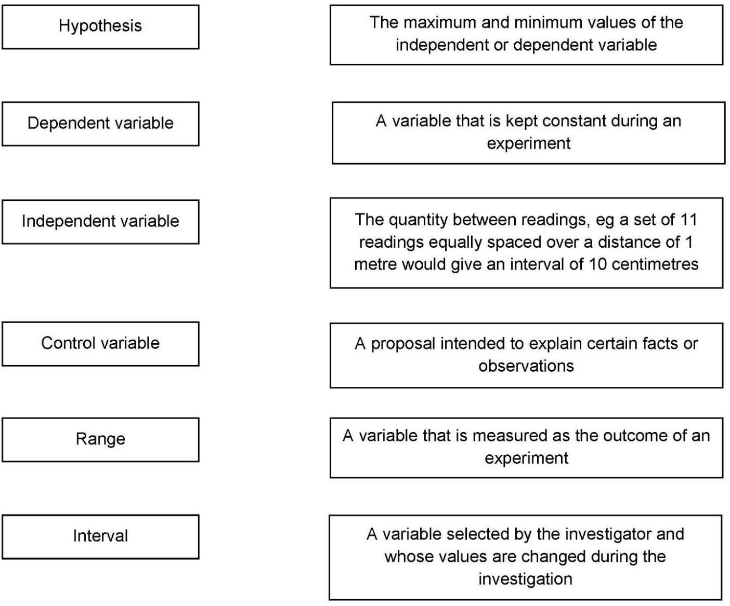

Activity 2 Scientific vocabulary: Making measurements
Link each term on the left to the correct definition on the right.

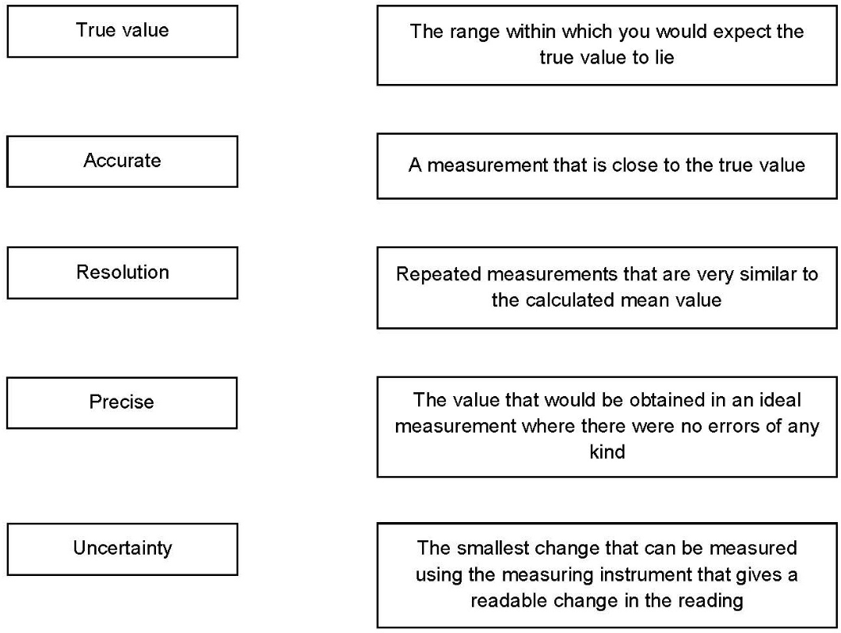

Activity 3 Scientific vocabulary: Errors
Link each term on the left to the correct definition on the right.

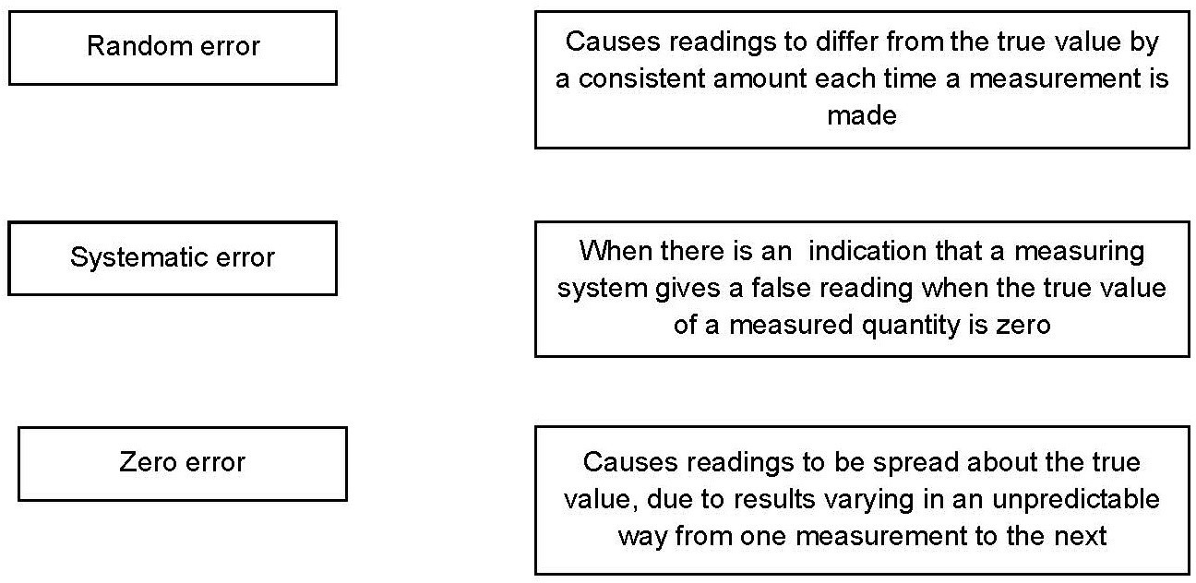
Understanding and using SI units
All measurements have a size (eg 2.7) and a unit (eg metres or kilograms).
Sometimes, there are different units available for the same type of measurement. For example, milligram, gram, kilogram and tonne are all units used for mass. Some values like strain and refractive index are not followed by a unit.

To reduce confusion, and to help with conversion between different units, there is a standard system of units called the SI units which are used for most scientific purposes.

These units have all been defined by experiment so that the size of, say, a metre in the UK is the same as a metre in China.
There are seven SI base units, which are given in the table.

Physical quantity | Unit | Abbreviation
Mass | kilogram | kg
Length | metre | m
Time | second | s
Electric current | ampere | A
Temperature | kelvin | K
Amount of substance | mole | mol
luminous intensity | candela | cd

All other units can be derived from the SI base units. For example, area is measured in metres square (written as m2) and speed is measured in metres per second
(written as m s–1 this is a change from GCSE, where it would be written as m/s).

Some derived units have their own unit names and abbreviations, often when the combination of SI units becomes complicated. Some common derived units are given in the table below.

Physical quantity | Unit | Abbreviation | SI unit
Force | newton | N | kg m s–2
Energy | joule | J | kg m2 s–2
Frequency | hertz | Hz | s–1
Using prefixes and powers of ten
Very large and very small numbers can be complicated to work with if written out in full with their SI unit. For example, measuring the width of a hair or the distance from Manchester to London in metres (the SI unit for length) would give numbers with a lot of zeros before or after the decimal point, which would be difficult to work with.
So, we use prefixes that multiply or divide the numbers by different powers of ten to give numbers that are easier to work with. You will be familiar with the prefixes milli (meaning 1/1000), centi (1/100), and kilo (1 × 1000) from millimetres, centimetres and kilometres.
There is a wide range of prefixes. Most of the quantities in scientific contexts will be quoted using the prefixes that are multiples of 1000. For example, we would quote a distance of 33 000 m as 33 km.

Kg is the only base unit with a prefix.
The most common prefixes you will encounter are given in the table.

Prefix | Symbol | Power of 10 | Multiplication factor
Tera | T | 1012 | 1 000 000 000 000
Giga | G | 109 | 1 000 000 000
Mega | M | 106 | 1 000 000
kilo | k | 103 | 1000
deci | d | 10-1 | 0.1 | 1/10
centi | c | 10-2 | 0.01 | 1/100
milli | m | 10-3 | 0.001 | 1/1000
micro | μ | 10-6 | 0.000 001 | 1/1 000 000
nano | n | 10-9 | 0.000 000 001 | 1/1 000 000 000
pico | p | 10-12 | 0.000 000 000 001 | 1/1 000 000 000 000
femto | f | 10–15 | 0.000 000 000 000 001 | 1/1 000 000 000 000 000

Activity 4 SI units and prefixes
- Re-write the following quantities using the correct SI units.

  - 1 minute
  - 1 milliamp
  - 1 tonne

- What would be the most appropriate unit to use for the following measurements?

  - The wavelength of a wave in a ripple tank
  - The temperature of a thermistor used in hair straighteners
  - The half-life of a source of radiation used as a tracer in medical imaging
  - The diameter of an atom
  - The mass of a metal block used to determine its specific heat capacity
  - The current in a simple circuit using a 1.5 V battery and bulb

Activity 5 Converting data
Re-write the following quantities.

- 1.5 kilometres in metres

- 450 milligrams in kilograms

- 96.7 megahertz in hertz

- 5 nanometers in metres

- 3.9 gigawatts in watts

Practical skills
The practical skills you learnt at GCSE will be further developed through the practicals you undertake at A-level. Your teacher will explain in more detail the requirements for practical work in Physics.
There is a practical handbook for AS and A-level Physics, which has lots of very useful information to support you in developing these important skills. You can download a copy here.

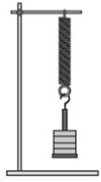
Activity 6 Investigating springs

A group of students investigated how the extension of a spring varied with the force applied. They did this by hanging different weights from the end of the spring and measuring the extension of the spring for each weight.

The results are below.

Weight added to the spring / N | Extension of spring / cm
Weight added to the spring / N | Trial 1 | Trial 2 | Trial 3 | Mean
2 | 3.0 | 3.1 | 3.2
4 | 6.0 | 5.9 | 5.8
6 | 9.1 | 7.9 | 9.2
8 | 12.0 | 11.9 | 12.1
10 | 15.0 | 15.1 | 15.12

- What do you predict the result of this investigation will be?

- What are the independent, dependent and control variables in this investigation?

- What is the difference between repeatable and reproducible?

- What would be the most likely resolution of the ruler you would use in this investigation?

- Suggest how the student could reduce parallax errors when taking her readings.

- Random errors cause readings to be spread about the true value.

What else has the student done in order to reduce the effect of random errors and make the results more precise?

- Another student tries the experiment but uses a ruler which has worn away at the end by 0.5 cm. What type of error would this lead to in his results?

- Calculate the mean extension for each weight.

- A graph is plotted with force on the y axis and extension on the x axis. What quantity does the gradient of the graph represent?

Greek letters
Greek letters are used often in science. They can be used:
    - as symbols for numbers (such as π = 3.14…)
    - as prefixes for units to make them smaller (eg μm = 0.000 000 001 m)
    - as symbols for particular quantities.
The Greek alphabet is shown below.

Capital letter | Lower case  letter | Name |  | Capital letter | Lower case  letter | Name |  | Capital letter | Lower case  letter | Name
Α | α | alpha |  | Ι | ι | iota |  | Ρ | ρ | rho
Β | β | beta |  | Κ | κ | kappa |  | Σ | ς or σ | sigma
Γ | γ | gamma |  | Λ | λ | lambda |  | Τ | τ | tau
Δ | δ | delta |  | Μ | μ | mu |  | Υ | υ | upsilon
Ε | ε | epsilon |  | Ν | ν | nu |  | Φ | φ | phi
Ζ | ζ | zeta |  | Ξ | ξ | ksi |  | Χ | χ | chi
Η | η | eta |  | Ο | ο | omicron |  | Ψ | ψ | psi
Θ | θ | theta |  | Π | π | pi |  | Ω | ω | omega

Activity 7 Using Greek letters
Use your knowledge from GCSE to complete the table. The first line has been completed for you.

Object or quantity represented by the Greek letter | Greek letter
Wavelength | λ
Type of ionising radiation which cannot pass through paper and is used in smoke detectors
 | Ω
Type of ionising radiation which is an electron ejected from the nucleus. Can be used to monitor paper thickness
Very short wavelength electromagnetic wave

The Physics formula and data sheet
You will need to use the AQA Physics formula and data sheet in your exams.
You can download a copy here.

Activity 8 Using the Physics formula and data sheet
- Use the sheet to find the symbols used to represent the following particles. (You will learn about these particles when you study particle physics.)

  - Photon
  - Neutrino
  - Muon
  - Meson (two letters used depending on type of meson)

- Look through the Electricity and Materials formula sections on the data sheet.

There is one Greek letter that is used to represent two different quantities. Give the letter and the quantities is it used to represent.

The delta symbol (Δ)

The delta symbol (Δ) is used to mean ‘change in’. For example, at GCSE, you would have
learned the formula:

 | distance |  |  | d
speed | = | which can be written as | s | =
 | time |  |  | t

What you often measure is the change in the distance of the car from a particular point, and the change in time from the beginning of your measurement to the end of it.

change in distance along road
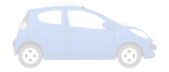
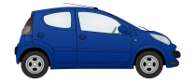

time at starting point of measurement
change in time

time at end point of measurement

As the distance and the speed are changing, you use the delta symbol to emphasise this. The A-level version of the above formula becomes:

 | displacement |  |  | Δs
velocity | = | which can be written as | v | =
 | time |  |  | Δt

Note: the delta symbol is a property of the quantity it is with, so you treat ‘Δs’ as one thing when rearranging, and you cannot cancel the delta symbols in the equation above.

Activity 9 Using the delta symbol
- What is the difference between:

  - speed and velocity
  - distance and displacement

- Look at the A-level Physics formula sheet (https://filestore.aqa.org.uk/sample- papers-and-mark-schemes/2018/june/AQA-74081-INS-JUN18.PDF) .

Which equations look similar to ones you used at GCSE, but now include the delta symbol?

- A coffee machine heats water from 20 °C to 90 °C. The power output of the coffee machine is 2.53 kW. The specific heat capacity of water is 4200 J/kg °C
Calculate the mass of water that the coffee machine can heat in 20 s.

- An unused pencil has a length of 86.0 mm.

A student uses the pencil to draw 20 lines on a piece of paper. Each line has a length of 25 cm.
The length of the pencil has changed to 84.5 mm.

Calculate the length of line that would need to be drawn for the original length to be halved.

Rearranging formulas

Activity 10 Rearranging formulas
- Rearrange c = f λ to make f the subject.

m
- Rearrange ρ = V to make m the subject.
λD
- Rearrange w = s to make s the subject
- Rearrange P = I 2 R to make I the subject

- Rearrange E = ½ m v2 to make v the subject.

- Rearrange h f = φ + E_{k} to make φ the subject

- Rearrange v = u + a t to make a the subject.

- Rearrange s = u t + ½ a t2 to make a the subject.

- Rearrange ε = I(R + r) to make r the subject.
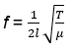
- Rearrange to make T the subject.

Using maths skills

Physics uses the language of mathematics to make sense of the world. It is important that you are able to apply maths skills in Physics. The maths skills you learnt and applied at GCSE are used and developed further at A-level.

Activity 11 Standard form
- Write the following numbers in standard form. a. 379 4
b. 0.0712

- Use the data sheet to write the following as ordinary numbers.

  - The speed of light
  - The charge on an electron

- Write one quarter of a million in standard form.

4. Write these constants in ascending order (ignoring units).

Permeability of free space The Avogadro constant Proton rest mass Acceleration due to gravity Mass of the Sun

Activity 12 Significant figures and rounding
- A rocket can hold 7 tonnes of material.

Calculate how many rockets would be needed to deliver 30 tonnes of material to a space station.

- A power station has an output of 3.5 MW.

The coal used had a potential output of 9.8 MW. Calculate the efficiency of the power station.
Give your answer as a percentage to an appropriate number of significant figures.

- A radioactive source produces 17 804 beta particles in 1 hour.

Calculate the mean number of beta particles produced in 1 minute. Give your answer to one significant figure.

Activity 13 Fractions, ratios and percentages
- The ratio of turns of wire on a transformer is 350 : 7000 (input : output) What fraction of the turns are on the input side?
- A bag of electrical components contains resistors, capacitors and diodes.

${\text{2}}/{\text{5}}$ of the components are resistors.
The ratio of capacitors to diodes in a bag is 1 : 5. There are 100 components in total.

How many components are diodes?

- The number of coins in two piles are in the ratio 5 : 3. The coins in the first pile are all 50p coins. The coins in the second pile are all £1 coins.

Which pile has the most money?

- A rectangle measures 3.2 cm by 6.8 cm. It is cut into four equal sized smaller rectangles.

Work out the area of a small rectangle.

- Small cubes of edge length 1 cm are put into a box. The box is a cuboid of length 5 cm, width 4 cm and height 2 cm.

How many cubes are in the box if it is half full?

- In a circuit there are 600 resistors and 50 capacitors. 1.5% of the resistors are faulty. 2% of the capacitors are faulty.

How many faulty components are there altogether?

- How far would you have to drill in order to drill down 2% of the radius of the Earth?

- Power station A was online 94% of the 7500 days it worked for. Power station B was online ${\text{8}}/{\text{9}}$ of the 9720 days it worked for. Which power station was offline for longer?

Activity 14 Pythagoras’ theorem
- Calculate the length of side x.

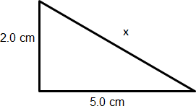

- Calculate the length of side x.

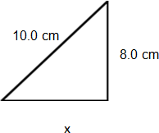

Activity 15 Using sine, cosine and tangent
- Calculate length AB

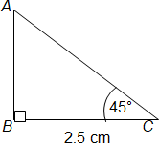
(not drawn to scale)

- Calculate length PR

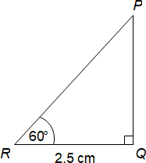

(not drawn accurately)

Activity 16 Arithmetic means
- The mean mass of 9 people is 79 kg.

A 10th person is such that the mean mass increases by 1 kg What is the mass of the 10th person?
- A pendulum completes 12 swings in 150 s.

Calculate the mean swing time.

Activity 17 Gradients and areas
- A car is moving along a road. The driver sees an obstacle in the road at time t = 0
and applies the brakes until the car stops.

The graph shows how the velocity of the car changes with time.
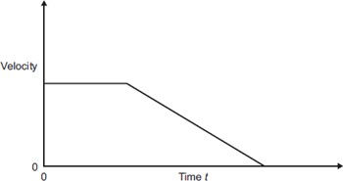

From the list below, which letter represents:
  - the negative acceleration of the car
  - the distance travelled by the car?

- The area under the graph
- The gradient of the sloping line
- The intercept on the y axis

2. The graph shows how the amount of energy transferred by a kettle varies with time.

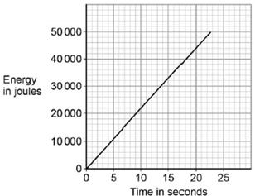
The power output of the kettle is given by the gradient of the graph. Calculate the power output of the kettle.

Activity 17 Gradients and areas
- The graph shows the speed of a car between two sets of traffic lights.

It achieves a maximum speed of v metres. per second. It travels for 50 seconds.
The distance between the traffic lights is 625 metres.
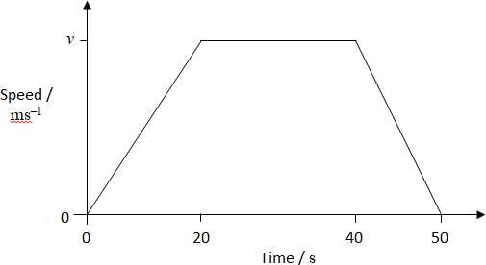

Calculate the value of v.

- The graph shows the speed of a train between two stations.
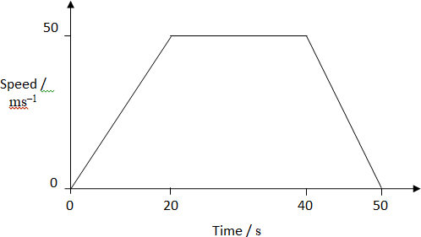

(not drawn accurately)

Calculate the distance between the stations.

Activity 18 Using and interpreting data in tables and graphs
- The graph shows the motion of a car in the first 10 seconds of its journey.

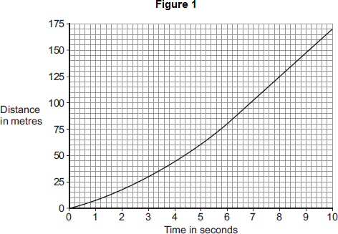

Use the graph to calculate the maximum speed the car was travelling at.

- The figure below is a speed–time graph for a sprinter at the start of a race.

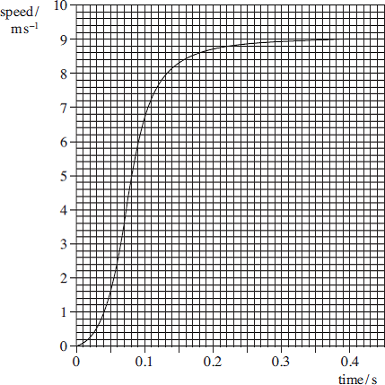

Determine the distance covered by the sprinter in the first 0.3 s of the race.

Activity 18 Using and interpreting data in tables and graphs
- The graph shows the speed–time graph of a car.

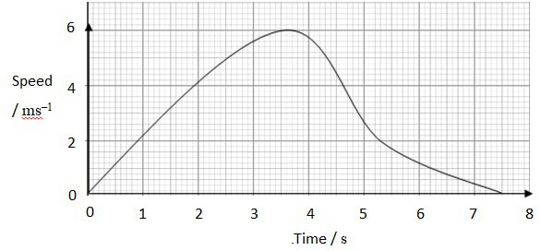

Use the graph to determine:

  - the maximum speed of the car
  - the total distance travelled
  - the average speed for the journey.

Activity 18 Using and interpreting data in tables and graphs
- The diagram shows the apparatus used by a student to measure the acceleration due to gravity (g).
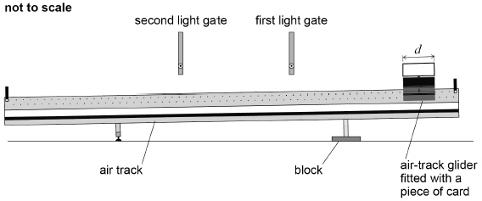

In the experiment:
- a block is used to raise one end of the air track
- an air-track glider is released from rest near the raised end of the air track and passes through the first light gate and then through the second light gate
- a piece of card of length d fitted to the air-track glider interrupts a light beam as the air-track glider passes through each light gate
- a data logger records the time taken by the piece of card to pass through each light gate and also the time for the piece of card to travel from one light gate to the other.

- The table gives measurements recorded by the data logger.

Time to pass through first light gate / s | Time to pass through second light gate / s | Time to travel from first to second light gate / s
0.50 | 0.40 | 1.19

The length d of the piece of card is 10.0 cm.

Assume there is negligible change in velocity while the air-track glider passes through a light gate.

Determine the acceleration a of the air-track glider.

- Additional values for the acceleration of the air-track glider are obtained by further raising the end of the air track by using a stack consisting of identical blocks.

Adding each block to the stack raises the end of the air track by the same distance.

Activity 18 Using and interpreting data in tables and graphs
Below is a graph of these results showing how a varies with n, the number of blocks in the stack.
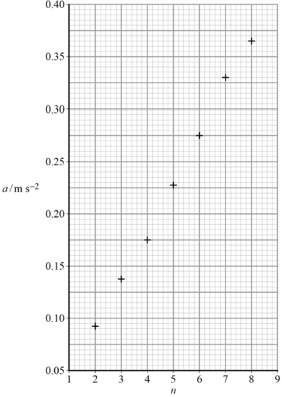

Draw a line of best fit and then determine the gradient of your line (A).

- It can be shown that, for the apparatus used by the student, g is equal to $\frac{\text{2}\text{A}}{\text{h}}$ where h is the thickness of each block used in the experiment.

The student obtains a value for g of 9.8 m s^{–2}

Calculate h.

Activity 18 Using and interpreting data in tables and graphs
- The power P dissipated in a resistor of resistance R is measured for a range of values of the potential difference V across it. The results are shown in the table.

V / V | V 2 / V2 | P / W
1.00 | 1.0 | 0.21
1.71 | 2.9 | 0.58
2.25 |  | 1.01
2.67 |  | 1.43
3.00 | 9.0 | 1.80
3.27 | 10.7 | 2.18
3.50 | 12.3 | 2.43

  - Complete the table.

  - Complete the graph below, and draw a line of best fit.
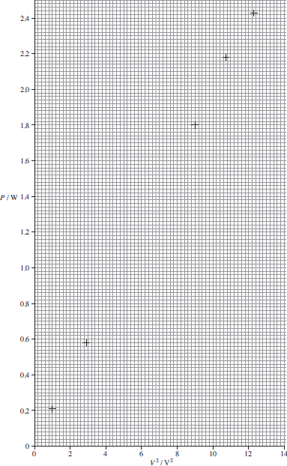

Activity 18 Using and interpreting data in tables and graphs
  - Determine the gradient of the graph.

  - Use the gradient of the graph to obtain a value for R.

The relationship is power = potential difference 2 / resistance
- To answer these questions, you will need a copy of the A-level Physics formula sheet.

In an experiment, a set of LEDs that emitted light of different colours was used.

The table below shows the data collected.

Colour | Wavelength  λ / nm | Frequency  f / 1014 Hz | Minimum pd  V_{min} /V
Infrared | 940 | 3.19 | 0.92
Red | 665 | 4.51 | 1.54
Orange | 625 | 4.80 | 1.54
Yellow | 595 | 5.04 | 1.78
Green | 565 |  | 1.87
Blue | 470 |  | 2.37

  - Complete the missing values for frequency.

  - Complete the graph by plotting the missing two points and drawing a line of best fit.

Activity 18 Using and interpreting data in tables and graphs
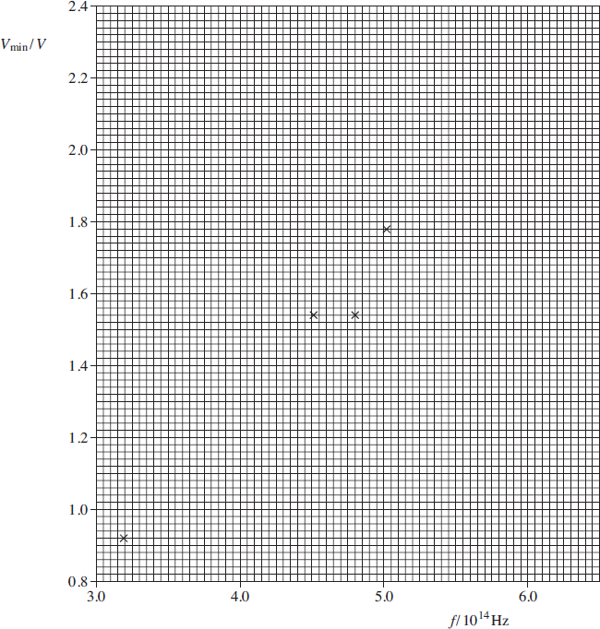

- Determine the gradient of the graph.

- Theory predicts that the energy lost by the electron in passing through the LED is the energy of the emitted photon. Hence

eV_{min} = hf,

where h is the Planck constant and e = 1.60 × 10−19 C.

Find a value for h by using the general equation of a straight line, y = mx + c, and your answer to part (c).

- The accepted value for h = 6.63 × 10−34 J s. Calculate the percentage difference between the value calculated in part (d) and the accepted value.

