GCE A Level Computer Science
Bridging Task (Year 11 to 12)
TASK
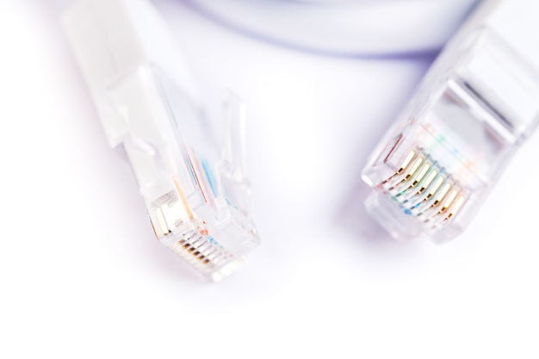
This bridging task is a research project. Create a technical report (in a word processor; e.g. MS Word or Google Docs) of no less than 10 sides on ‘Networks’. This should take around 5 to 7 hours to complete. Describe the following topics:
- Characteristics of networks and [5]
the importance of protocols and standards. [5]
- The internet structure: [10]
  - The TCP/IP Stack
  - DNS
  - Protocol layering
  - LANs and WANs
  - Packet and circuit switching.
- Network security and threats, use of firewalls, proxies and encryption. [10]
- Network hardware. [5]
- Client-server and peer to peer. [5]
Your report must:
- Include diagrams and pictures where appropriate.
- Discuss and explain the technologies
- Look at the various advantages and disadvantages of each of the technologies.
- Have been spell and grammar checked without any (or minimal) errors in your English. It will also help if you have had your work proof read.
For top marks you will have used the resources listed on the next page as well as identifying and using your own resources. List out all of the resources used in a Bibliography (to be included as an appendix):
Example Bibliography Format
1) TCP / IP An animated discussion - https://www.youtube.com/watch?v=RbY8Hb6abbg
I found this YouTube video which described how TCP-IP is used in networks. Viewed 29/06/2020.
2) Features of computer network topologies - http://www.teach-ict.com/gcse_computing/ocr/215_communications_networking/network_topologies/theory_network_ topologies.html. Covers networking (LAN and WAN). Publishers www.teach-ict.com. Viewed 29/06/2020.

RESOURCES
Use the following resources to help you carry out your research:
- Features of computer networks LANS and WANS (Craig’n’Dave YouTube)
OCR A Level (H046-H446) LANs and WANs - YouTube
Covers networking (LAN and WAN). A concise account that does not go into too much detail.
- Features of computer network topologies (Craig’n’Dave YouTube)
AQA A’Level Networking topologies - YouTube
Covers network topologies.
- The internet (BBC Bitesize)
http://www.bbc.co.uk/education/guides/zp9jpv4/revision/1
Covers how the internet works including protocols. Nice diagrams and a test.
- Features of network addressing (Craig’n’Dave YouTube)
OCR GCSE (J277) 1.3 The use of IP and MAC addressing - YouTube
Covers IP addressing, MAC addressing and protocols.
- TCP/IP – an animated discussion (YouTube video)
https://www.youtube.com/watch?v=RbY8Hb6abbg
An animated discussion about how data is moved around on the internet. Topics include TCP/IP, Routing Information Protocol (RIP), Open Shortest Path First Protocol (OSPF), Border Gateway Protocol (BGP), Backbones, Autonomous Systems, Interior Gateway Protocols, Exterior Gateway Protocols, Hiding.
- Security (BBC Bitesize)
http://www.bbc.co.uk/education/guides/zs87sbk/revision
Covers viruses, encryption and acceptable use.
- Network hardware (BBC Bitesize)
http://www.bbc.co.uk/education/guides/zh4whyc/revision
Covers LANs and WANs, topologies, wired and wireless connections, networking hardware, client-server, P2P, types of server.
- Network hardware (Craig’n’Dave YouTube)
OCR A Level (H446) Network hardware - YouTube
Covers network hardware in the OCR A Level.
- Client server (Craig’n’Dave YouTube)
OCR A Level (H046-H446) Client-server and peer-to-peer - YouTube
Covers difference between client-server and P2P networks.

