A-Level Biology transition



The Astley Cooper School

Name: ________________

Contents | Page
Understanding the specification and the assessment | 3
Transition activities 1-3: Scientific vocabulary | 8-10
Transition activity 4: SI Units and prefix | 12
Transition activity 5: Units | 12
Transition activity 6: Converting data | 13
Transition activity 7: Investigating enzymes | 14-15
Transition activity 8: Mean mode median and scatter graphs | 16-17
Transition activity 9: Data in tables | 18
Transition activity 10: Analysing complex graphs | 19
Transition activity 11: Extended writing | 20
Transition activity 12 Cell structure and magnification | 21-22
Transition activity 13 Cell division | 23
Transition activity 14 Transport across cell membranes | 24-25
Transition activity 15 Digestion and food tests | 26
Transition activity 16 Circulatory system and gas exchange | 27
Transition activity 17 DNA and genetics | 28
Transition activity 18 monoclonal antibodies | 29

Aim of the booklet
This booklet will support your transition from GCSE science to A-level. At first, you may find the jump in demand a little daunting, but if you follow the tips and advice in this guide, you’ll soon adapt. As you follow the course you will see how the skills and content you learnt at GCSE will be developed and your knowledge and understanding of all these elements will progress.

We have organised the guide into three sections:
- Understanding the specification and the assessment
- Transition activities to bridge the move from GCSE to start of the A-level course
- Progression of key ideas from GCSE to A-level.

Understanding the specification and the assessments
Specification at a glance
The specification is a useful reference document for you. You can download a copy from our website here.
The most relevant parts of the specification for students are the following:
Section 3: Subject content
Section 6: Maths requirements and examples
Section 7: Practical assessment

In Biology, the subject content is split between AS and A level (sections 3.1 – 3.4) and A level only (sections 3.5-3.8). The section titles are listed here:

  - Biological molecules
  - Cells
  - Organisms exchange substances with their environment
  - Genetic information, variation and relationships between organisms
  - Energy transfers in and between organisms (A level only)
  - Organisms respond to changes in their internal and external environments (A level only)
  - Genetics, populations evolution and ecosystems (A level only)
  - The control of gene expression (A level only)

Each section of the content begins with an overview, which describes the broader context and encourages an understanding of the place each section has within the subject. This overview will not be directly assessed.

The specification is presented in a two-column format:
- the left-hand column contains the specification content that must cover, and that can be assessed in the written papers.
- the right-hand column exemplifies the opportunities for maths and practical skills to be developed throughout the course. These skills can be are assessed through any of the content on the written papers not necessarily in the topics we have signposted.

Assessment structure
The assessment for the A-level consists of three exams, which you will take at the end of the course.
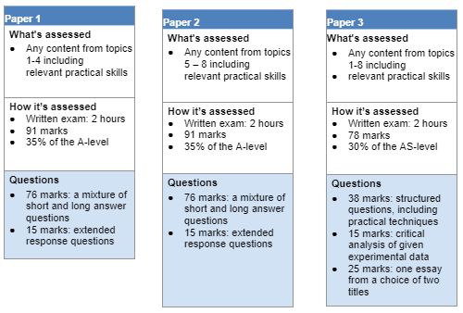

Assessment objectives

As you know from GCSE, we have to write exam questions that address the Assessment objectives (AOs). It is important you understand what these AOs are, so you are well prepared. In Biology there are three AOs.

- AO1: Demonstrate knowledge and understanding of scientific ideas, processes, techniques, and procedures (A-level about 30-35% of the marks).
- AO2: Apply knowledge and understanding of scientific ideas, processes, techniques, and procedures;
- in a theoretical context
- in a practical context
- when handling qualitative data
- when handling quantitative data
(A-level about 40-45% of the marks).
- AO3: Analyse, interpret, and evaluate scientific information, ideas, and evidence, including in relation to;
  - make judgements and reach conclusions
  - develop and refine practical design and procedures
(A-level about 25–30% of the marks).

Other assessment criteria

At least 10% of the marks for AS and A-level Biology will assess mathematical skills, which will be equivalent to Level 2 (Higher Tier GCSE Mathematics) or above.

At least 15% of the overall assessment of AS and A-level Biology will assess knowledge, skills and understanding in relation to practical work.

Command words
Command words are used in questions to tell you what is required when answering the question. You can find definitions of the command words used in Biology assessments on the website. They are very similar to the command words used at GCSE

Subject-specific vocabulary
You can find a list of definitions of key working scientifically terms used in our AS and A-level specification here.
You will become familiar with, and gain understanding of, these terms as you work through the course.

Transition activities

The following activities cover some of the key skills from GCSE science that will be relevant at AS and A-level. They include the vocabulary used when working scientifically and some maths and practical skills.

You can do these activities independently or in class. The booklet has been produced so that it can be completed electronically or you can print them out.

The activities are not a test. Try the activities first and see what you remember and then use textbooks or other resources to answer the questions. Don’t just go to Google for the answers, as actively engaging with your notes and resources from GCSE will make this learning experience much more worthwhile.
The answer booklet guides you through each answer. It is not set out like an exam mark scheme but is to help you get the most out of the activities.
Understanding and using scientific vocabulary
Understanding and applying the correct terms are key for practical science. Much of the vocabulary you have used at GCSE for practical work will not change but some terms are dealt with in more detail at A-level so are more complex.

Activity 1 Scientific vocabulary: Designing an investigation
Link each term on the left to the correct definition on the right.

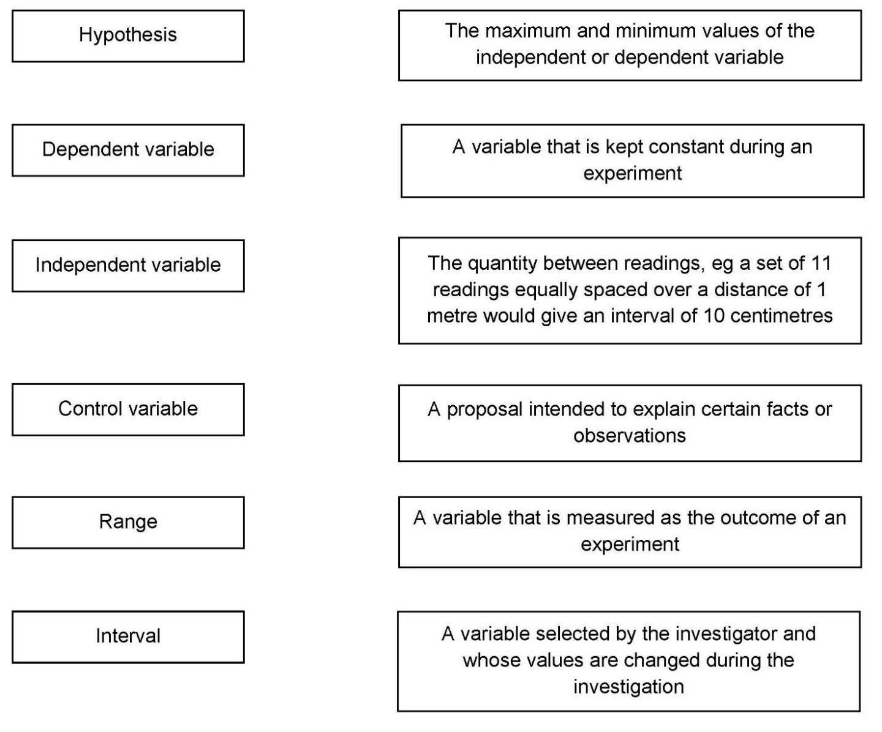

Activity 2 Scientific vocabulary: Making measurements
Link each term on the left to the correct definition on the right.

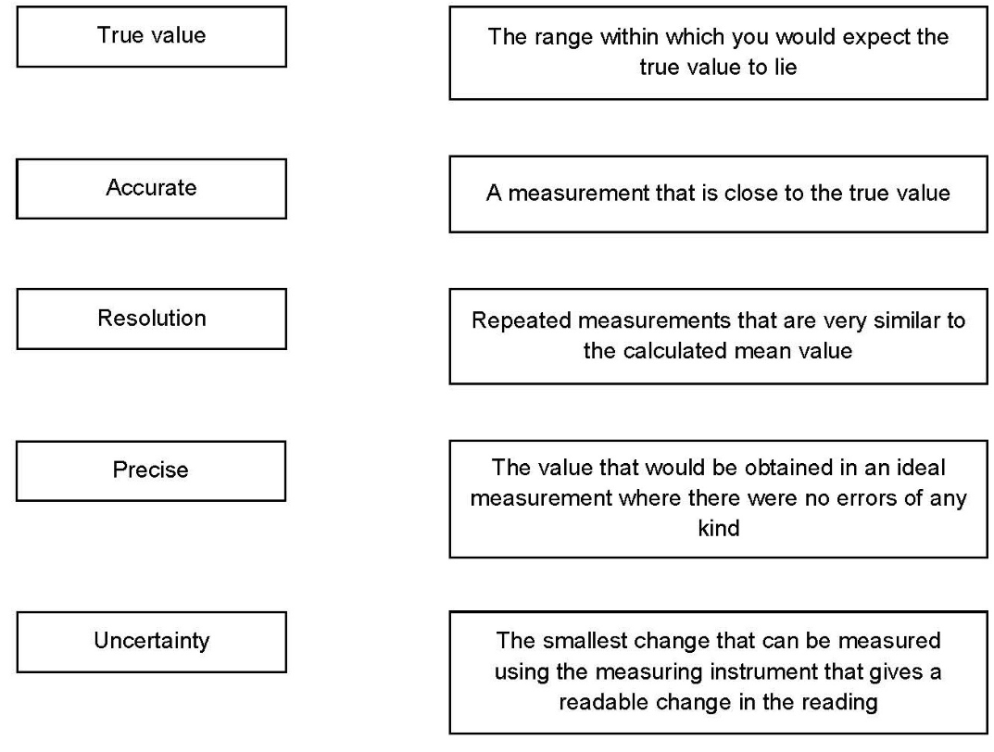

Activity 3 Scientific vocabulary: Errors
Link each term on the left to the correct definition on the right

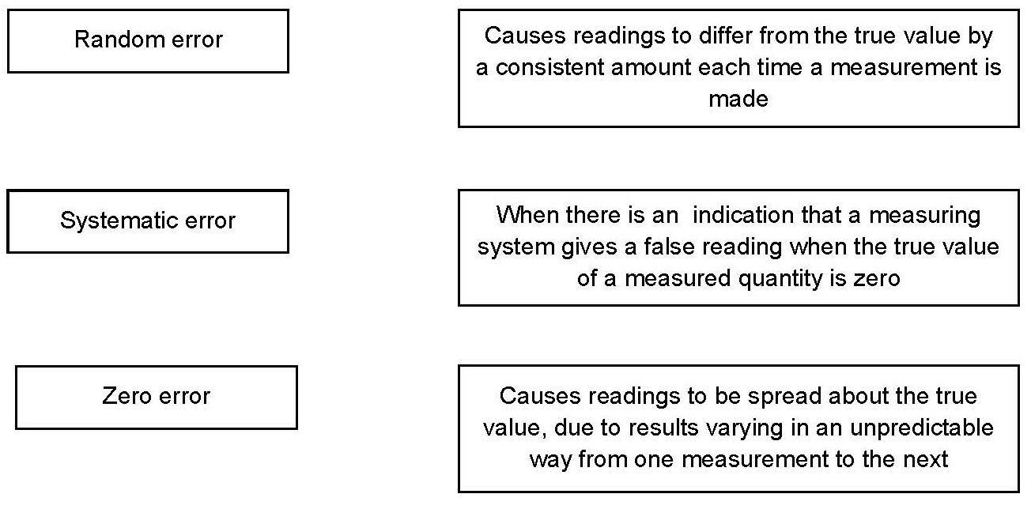

Understanding and using SI units

Every measurement has a size (eg 2.7) and a unit (eg metres or kilograms). Sometimes, there are different units available for the same type of measurement. For example, milligram, gram, kilogram and tonne are all units used for mass.

To reduce confusion, and to help with conversion between different units, there is a standard system of units called the SI units which are used for most scientific purposes.

These units have all been defined by experiment so that the size of, say, a metre in the UK is the same as a metre in China.

There are seven SI base units, which are given in the table.

Physical quantity | Unit | Abbreviation
Mass | kilogram | kg
Length | metre | m
Time | second | s
Electric current | ampere | A
Temperature | kelvin | K
Amount of substance | mole | mol
luminous intensity | candela | cd

All other units can be derived from the SI base units. For example, area is measured in metres square (written as m²) and speed is measured in metres per second (written as m s^{–1,} this is a change from GCSE where it is written as m/s).

Using prefixes and powers of ten
Very large and very small numbers can be complicated to work with if written out in full with their SI unit. For example, measuring the width of a hair or the distance from Manchester to London in metres (its SI unit) would give numbers with a lot of zeros before or after the decimal point, which would be difficult to work with.
So, we use prefixes that multiply or divide the numbers by different powers of ten to give numbers that are easier to work with. You will be familiar with the prefixes milli (meaning 1/1000), centi (1/100), and kilo (1 × 1000) from millimetres, centimetres, and kilometres.
There is a wide range of prefixes. Most of the quantities in scientific contexts will be quoted using the prefixes that are multiples of 1000. For example, we would quote a distance of 33 000 m as
33 km.
The most common prefixes you will encounter are given in the table.

Prefix | Symbol | Power of 10 | Multiplication factor
Tera | T | 10¹² | 1 000 000 000 000
Giga | G | 10⁹ | 1 000 000 000
Mega | M | 10⁶ | 1 000 000
kilo | k | 10³ | 1000
deci | d | 10⁻¹ | 0.1 | 1/10
centi | c | 10⁻² | 0.01 | 1/100
milli | m | 10⁻³ | 0.001 | 1/1000
micro | μ | 10⁻⁶ | 0.000 001 | 1/1 000 000
nano | n | 10⁻⁹ | 0.000 000 001 | 1/1 000 000 000
pico | p | 10⁻¹² | 0.000 000 000 001 | 1/1 000 000 000 000
femto | f | 10^{–15} | 0.000 000 000 000 001 | 1/1 000 000 000 000 000

Activity 4 SI units and prefixes
What would be the most appropriate unit to use for the following measurements?
- The time between heart beats
- The diameter of a cheek cell
- The distance that a migratory bird travelled each year
- The thickness of a DNA helix
- The mass of a rabbit
- The mass of iron in the body
- The diameter of a glucose molecule

Activity 5 Units
Choose the most appropriate unit and estimate the size of each of the following.

- The mass of an earthworm

- The volume of water in a teardrop

- The volume of water in a garden pond

- The time taken for a sunflower to grow

- The temperature difference between the blood in the heart and in the ear on a cold day

- The diameter of a human hair

- The length that your fingernails grow each day

- The total length of DNA in one human body cell

Activity 6 Converting data
Re-write the following.

- 0.00224 metres in millimetres
- 104 micrograms in grams
- 6.2 kilometres in metres
- 10 micrograms in nanograms
- 70 decilitres in litres
- 10 cm³ in litres

Practical skills
The practical skills you learnt at GCSE will be further developed through the fieldwork and practicals you undertake at A-level. Your teacher will explain in more detail the requirements for fieldwork, practical work, and the research methods.

There is a practical handbook for Biology which has lots of very useful information to support you in developing these important skills. You can download a copy here.

Activity 7 Investigating how temperature and pH affect enzymes
Egg white is made of protein. The students were investigating how temperature and pH affect the digestion of protein
The students carried out the following procedure:
- Filled six narrow glass tubes with fresh egg white
- Boiled the tubes so the egg white became solid
- Placed each tube into a different beaker containing human protease enzyme at different pH values at room temperature and 3 in neutral pH but at different temperatures for 24 hours
- Measured the length of solid egg white in each tube after 24 hours
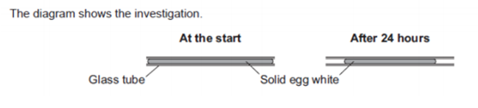
The results were recorded in the tables below:

pH | Original length of solid egg white (cm) | Final length of solid egg white (cm) | % change
4 | 6.0 | 5.6
7 | 6.0 | 3.8
9 | 6.0 | 5.8

Temperature ( °C) | Original length of solid egg white (cm) | Final length of solid egg white (cm) | % change
15 | 6.0 | 5.7
35 | 6.0 | 3.8
55 | 6.0 | 5.3

- State a hypothesis for this investigation.
- The students predicted that the enzyme would be most effective in conditions similar to those found in the human body. Was their prediction correct?
- Identify the independent and dependent variables in this investigation.
- Suggest the control variables for this investigation.
- Describe the difference between repeatable and reproducible.
- What would be the most likely resolution of the ruler you would use in this investigation.
- Suggest how repeating the investigation would be an improvement.
- Calculate the % change for each result in this investigation. Show your answers to 3 significant figures.

Analysing data
Biological investigations often result in large amounts of data being collected. It is important to be able to analyse this data carefully in order to pick out trends.

Activity 8 Mean mode median and scatter graphs
A student investigated an area of moorland where succession was occurring. The student used quadrats to measure the area covered by; different plant species, bare ground and surface water.
They did this every 10 metres along a line transect. The student also recorded the depth of soil at each quadrat. Their results are shown in the table.

 | Area covered in each quadrat A to E in cm²
 | A | B | C | D | E
Bog moss | 55 | 40 | 10 | – | –
Bell heather | – | – | – | 15 | 10
Sundew | 10 | 5 | – | – | –
Ling | – | – | – | 15 | 20
Bilberry | – | – | – | 15 | 25
Heath grass | – | – | 30 | 10 | 5
Soft rush | – | 30 | 20 | 5 | 5
Sheep’s fescue | – | – | 25 | 35 | 30
Bare ground | 20 | 15 | 10 | 5 | 5
Surface water | 15 | 10 | 5 | – | –
Soil depth / cm | 3.2 | 4.7 | 8.2 | 11.5 | 14.8
Calculate:
- Calculate the mode area of soft rush in the sample.
- Calculate the mean soil depth of the area of moorland sampled.
- Calculate the median amount of bare ground in the sample.

- Using the data in the table plot a scatter graph of the soil depth against the area covered by bare ground, soft rush and bog moss (use different colours or markers for each).
- What conclusions can you draw from this graph?
- Suggest how to improve the validity of these conclusions.



Activity 9 Data in tables
A patient with a leaking heart valve may have the valve replaced. A study compared two different types of replacement heart valve:
- mechanical valves
- biological valves from pigs.
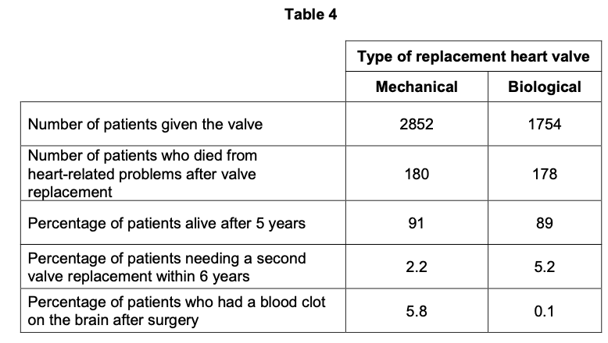
The data used in the study was collected from female patients aged 50–69. Table 4 shows the data

- Give one conclusion about the death of patients from heart-related problems after a valve replacement.
Include calculations to support your answer.
- Evaluate the use of mechanical replacement heart valves and biological replacement heart valves.
Use information from Table 4.

Activity 10 Analysing complex graphs
The volume of air breathed in and out of the lungs during each breath is called the tidal volume.
The breathing rate and tidal volume were measured for a cyclist pedaling at different speeds. The graph shows the results

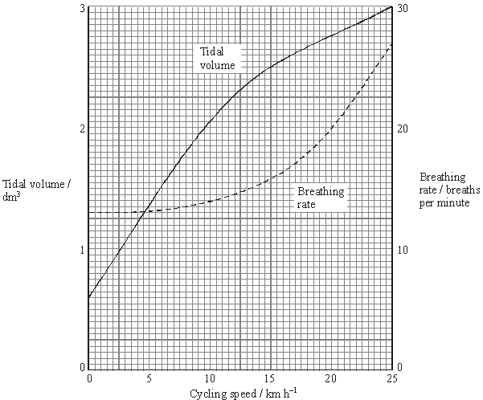

- State the tidal volume when the cycling speed was 17 km h^{–1}.
- State the breathing rate when the cycling speed was 8 km h^{–1}.
- Calculate the change in breathing rate when the cyclist speed changed from 10 to 20 km h¹.
Express this as a percentage.
- State the speed at which the breathing rate starts to increase.
- The tidal volume increased linearly with the cycling speed up to about 10 km h^{–1}. Calculate the increase in volume for each increase in speed of 1 km h^{–1}.

Extended writing
The ability to write coherently in a logical, well-structured way is an essential skill to develop. At GCSE the 6-mark extended response questions are used so students can demonstrate this skill. At A-level you need to develop this skill further, and you will be expected to write longer extended response questions, including an essay worth 25 marks. You will practice this skill over the next 2 years.
The command word in a question, like at GCSE, is important as it gives you an indication of what to include in your answers. For example, ‘explain’ means you must give reasons why things are happening, not just give a description. A comparison needs advantages and disadvantages or points for and against. Your teacher will work with you on this skill during the course.

Activity 11 Extended writing
This is an ‘open book’ activity, meaning you can use notes/ resources to help you.
Before attempting the question below, you might want to remind yourself of the work you did on the following topics at GCSE (using notes/ textbooks/ revision guides etc):
- the theory of evolution
- the role of mutation and natural selection
Lemurs are only found on the island of Madagascar. Madagascar is off the coast of Africa. Scientists think that ancestors of modern lemurs evolved in Africa and reached Madagascar about 50-60 million years ago.
Today there are many species of lemur living on Madagascar
Figure 1 shows the distribution of three species of lemur on Madagascar.
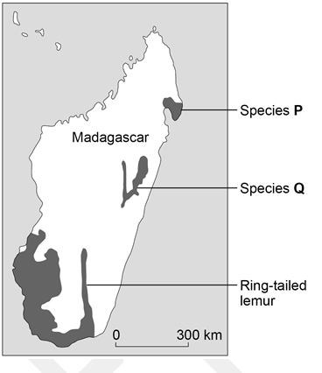

Describe how the ancestors of modern lemurs may have evolved into the three different species shown on the map (species P, species Q and ring tail lemurs)

Progression of content
What you learnt at GCSE forms the foundation to your further study at A-level. Ideas will be developed and refined, new concepts and skills will be introduced. The follow are some optional questions which you might like to have a go at. They are designed to help refresh your memory of some of the important concepts you will use during your study of AS and A -level Biology.
Use the questions in each section to help to identify where your knowledge and understanding is secure and which areas you may need to revisit.
Activity 12 Cell structure and magnification
Drawing images from microscope observations must be done carefully, including careful measurements for magnification calculations.
Make sure that you are clear on the organelles within different cells and their functions.
You must also be secure in the method used to make observations using a light microscope and the purpose of each method step.

Figure 1 shows an animal cell viewed using a microscope

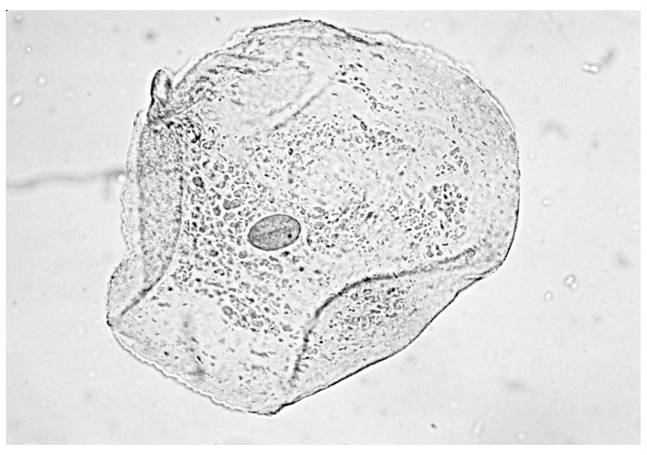
The cell contains a nucleus.
- State the function of the nucleus.
- Name one type of cell that does not contain a nucleus.
- On the diagram label three parts of the cell.
- Name one structure found in a plant cell but not found in an animal cell.

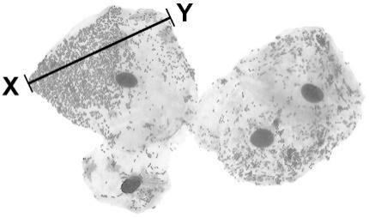
The figure below shows some different cells.

The real length from point X to point Yi s 0.06 mm.
- Calculate the magnification.
The cells shown above were viewed using a light microscope.
- Give two advantages of using an electron microscope instead of a light microscope.

Activity 13 Cell division
There is sometimes confusion between how and cells divide by mitosis and meiosis. You need to understand the purpose and features of each process and the role of mitosis in the cell cycle.
Cell division is needed for growth and for reproduction.
Table 3 contains three statements about cell division.
Complete Table 3 by ticking one box for each statement.
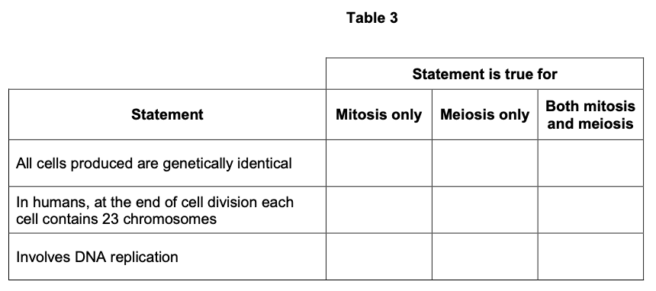

Activity 14: Transport across cell membranes
In Biology, many processes involve moving substances across boundaries. Ensure that you know what each of diffusion, osmosis and active transport are and where each takes place. Questions on transport across cell membranes often involve data and applying knowledge and understanding to unfamiliar contexts.
One of the required practicals at GCSE is on osmosis, make sure that you can interpret the graph used to show the results.
A student carried out an investigation using chicken eggs. This is the method used.
- Place 5 eggs in acid for 24 hours to dissolve the egg shell.
- Measure and record the mass of each egg.
- Place each egg into a separate beaker containing 200 cm³ of distilled water.
- After 20 minutes, remove the eggs from the beakers and dry them gently with a paper towel.
- Measure and record the mass of each egg. Table 4 shows the results.
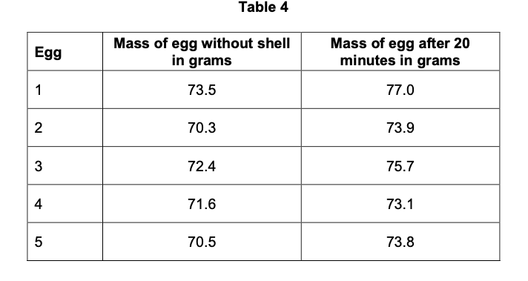
Another student suggested that the result for egg 4 was anomalous.
- Do you agree with the student?
Give a reason for your answer.
- Calculate the percentage change in mass of egg 3.
- Explain why the masses of the eggs increased.
- Explain how the student could modify the investigation to determine the concentration of the solution inside each egg.

Chicken egg shells contain calcium. Calcium ions are moved from the shell into the cytoplasm of the egg.
Table 5 shows information about the concentration of calcium ions.
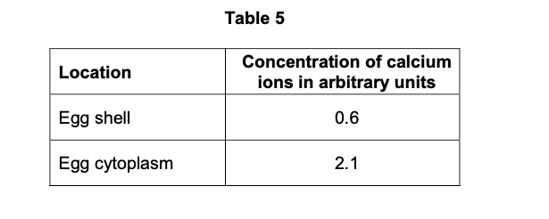
- Explain how calcium ions are moved from the shell into the cytoplasm of the egg.

Activity 15 Digestion and food tests
It is important to understand the role of enzymes in digestion and how enzymes work. Recalling the food tests is important, particularly how to test for protein and sugars.
- Describe how a student could test cow’s milk to show whether it contains protein and different types of carbohydrate.
A scientist investigated the effect of bile on the breakdown of fat in a sample of milk.
The scientist used an indicator that is colourless in solutions with a pH lower than 10, and pink in solutions with a pH above 10
This is the method used.
- Add 1 drop of bile to a test tube and one drop of water to a second test tube.
- Add the following to each test tube:
• 5 cm³ of milk
• 7 cm³ of sodium carbonate solution (to make the solution above pH 10)
• 5 drops of the indicator
• 1 cm³ of lipase.
- Time how long it takes for the indicator in the solutions to become colourless.
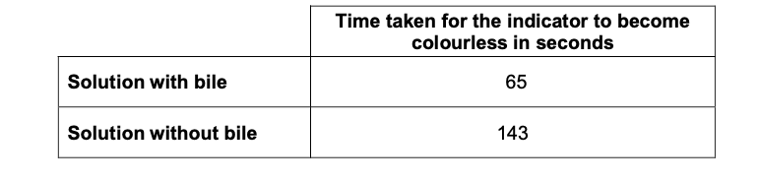
- Explain why the indicator in both tubes became colourless.
- Explain the difference in the results for the two test tubes in the table above

Activity 16 Circulatory system and gas exchange
Application of your knowledge and understanding of these key concepts to unfamiliar context is a way examiners can assess the depth of your understanding.
A small animal called an axolotl lives in water.

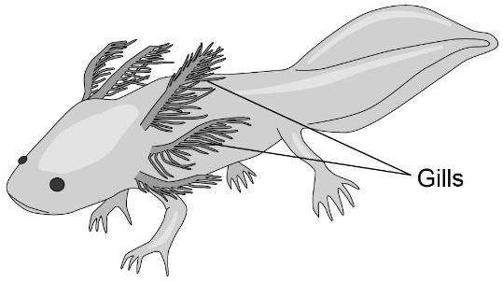
The axolotl has a double circulatory system.
- Explain what is meant by the term double circulatory system.
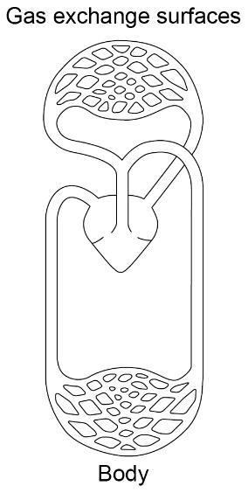
The diagram below shows the double circulatory system of the axolotl.

- The heart of the axolotl has only one ventricle. Label the ventricle on the diagram.
- Explain why having only one ventricle makes the circulatory system less efficient than having two ventricles.
- Explain why an axolotl may die in water with a low concentration of oxygen. Use the diagram above to help you, remember about surface area: volume ratio in gas exchange.

Activity 17 DNA and genetics
Genetic material is made of DNA.
- Name the structures in the nucleus of a human cell which contain DNA.
The figure below shows part of one strand of a DNA molecule.

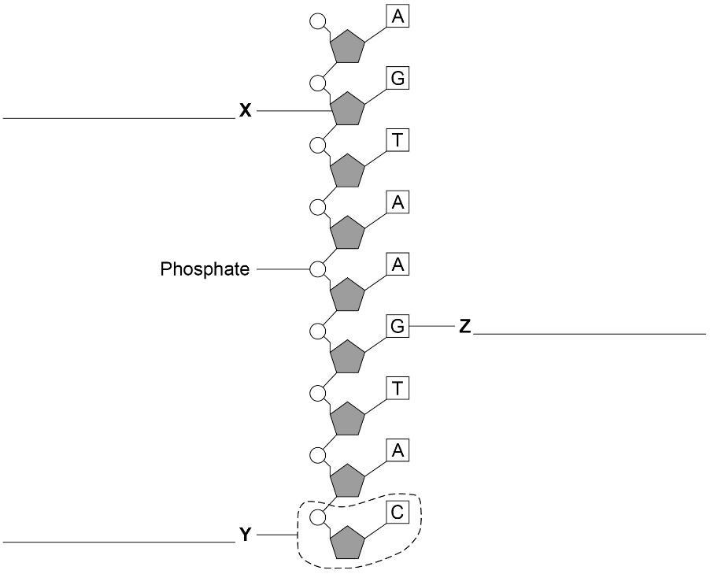

- Label parts X, Y and Z with the correct word from the list below :
base fatty acid nucleotide sugar glycerol
- A complete DNA molecule is made of two strands twisted around each other.
What scientific term describes this structure?
DNA codes for the production of proteins.
A protein molecule is a long chain of amino acids.
- How many amino acids could be coded for by the piece of DNA shown in the figure above?

Activity 18 Monoclonal antibodies
Monoclonal antibodies are identical copies of a specific type of antibody. Antibodies are extremely important as they are a type of protein that is produced by lymphocytes to fight pathogens (disease causing viruses, bacteria, fungi or protists). Pathogens have antigens on them which makes them unique. When a pathogen enters an organism and causes an infection, the lymphocyte recognises the unique antigen on the pathogen and start attacking them by producing antibodies. Monoclonal antibodies (copies) can be made in the lab.
A farmer thinks a potato crop is infected with potato virus Y (PVY). The farmer wants to buy a monoclonal antibody to get rid of the potato virus.
To make the monoclonal antibodies a scientist first isolates the PVY protein from the virus.
- Describe how the scientist would use the PVY protein to produce the PVY monoclonal antibody for the farmer.

