Year 12 Criminology
Transition work

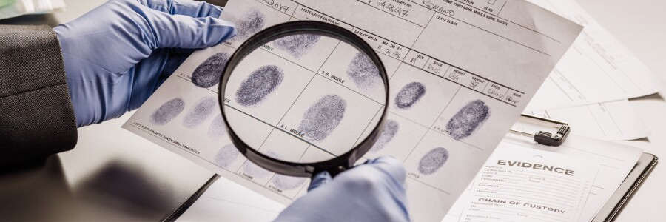

Name -

This is a detailed and comprehensive assignment that you have been given. Do not rush it. We advise that you complete the tasks gradually rather than leaving it all until the final week of your break.

If there are any questions please email c.ollerenshaw-east@astleycooper.herts.sch.uk


Task 1 - Criminology in the Media
Did you know that approximately 20% of films are crime related and around 46% of media reports focus on violent/sexual crime? With this mind, it makes sense that some people feel that crime is all around them. This task will widen your knowledge of the different ways crime is portrayed in the media. Pick 1 of the documentaries to watch from the list below and comment on the following.

- Amanda Knox
- Fred and Rose West - A British Horror Story
- American Nightmare
- American Murder Gabby Petito
- Disappearance of Madeline McCann
- When they see us
- Confessions of a killer: The Ted Bundy Tapes
- Making a Murderer
- The Innocence Files
- The People vs OJ Simpson or American Manhunt OJ Simpson
- The Trials of Gabriel Fernandez
- Killer Inside: The Mind of Aaron Hernandez
- Abducted in plain sight
- American Murder (The Family Next Door)

If you don’t have Netflix then please use any of the following Youtube videos
- Murder At Columbine High School
(https://www.youtube.com/watch?v=D9mUpUHk3nE)
- Hillsborough: anatomy of a disaster
(https://www.youtube.com/watch?v=PYNeoTXe-SE)
- Defending Violent Criminals
(https://www.youtube.com/watch?v=Q15bAd8s08I)
- Dr Death: Britain’s Biggest Serial Killer
(https://www.youtube.com/watch?v=3-KVuVjmjmU)
- Michelle Carter – Can Words Kill
(https://www.youtube.com/watch?v=MfAG4O7ojxE)
- Myra Hindley – Britain’s Most Hated Woman (https://www.youtube.com/watch?v=NQ8eKB5fJRk)
- The Boys Who Killed a Child (Jamie Bulger)
(https://www.youtube.com/watch?v=TrkQe4tyJnQ)

Title of Documentary
Brief overview of the case

Comment on the following
- Did the criminal get caught? If so, how?
- Did the criminal get away with it (either forever or for a long time)?
- Do we know why the criminal committed the crime?
- Is this a typical crime?
- What is the media representation of this crime/case like?
What did you find interesting about this case?

Task 2 - Serial Killer Fact File
Although criminology isn’t all about gruesome serial killers, it will be useful for you to have some prior knowledge of this type of crime before you study the course. During Year 12, you will learn various causes of criminal behaviour and you will be able to link these to various serial killers.

Choose a serial killer from the selection (or choose your own!) and research information according to the criteria below.

Please be mindful of this task, if it gets too much then please come back to it at a later day.
What is their background?
Where did they grow up? What was their family like? What was their life like before/during their crimes?
What crimes did they commit?
How many people did they murder? How did they murder? What did they do with the bodies?
Who were their victims? Did they have a certain ‘type’?
Were they caught? If so, how were they punished?
Is there anything which might explain their behaviour? i.e. any head injuries, childhood abuse?

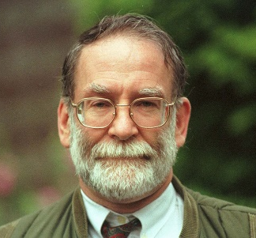  Harold Shipman | 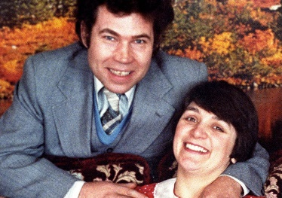  Fred and Rose West | 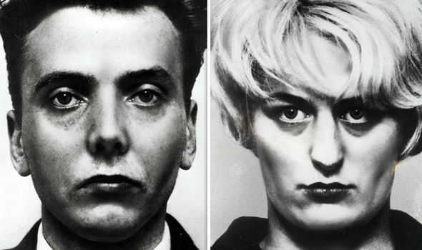  Ian Brady and Myra Hindley
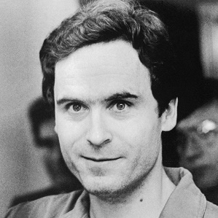  Ted Bundy | 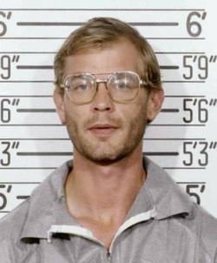  Jeffery Dahmer | 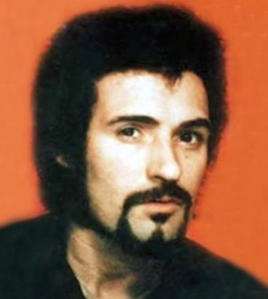  Peter Sutcliffe

TASK 3: CRIME
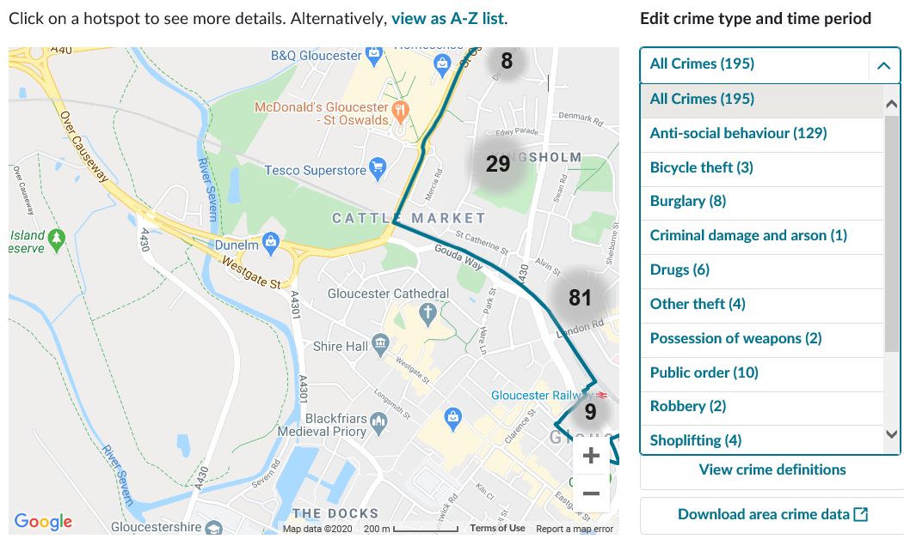
You will already know that different areas of the UK will have different crime rates but did you know that different areas have different types of crime?

Think about the difference between urban, built up areas compared to rural areas – what would the difference in types of crime be?

Use the two links below to look at the amount and types of crime that occur in Birmingham City Centre compared to Kingsholm and Wotton, a small area in Gloucester.

- https://www.police.uk/pu/your-area/west-midlands-police/city-centre/?tab=CrimeMap

- https://www.police.uk/pu/your-area/gloucestershire-constabulary/kingsholm-and-wotton/?tab=CrimeMap
What type of crimes were reported in Birmingham?
What types of crimes were reported in Gloucester?
What was the category with this hate crime?
Who are the potential victims?
What is the difference between an urban and rural area when it comes to crime?
Would that crime change if you looked in St Albans or Harpenden? Why/Why not?
Use the dropdown menu to see the different types of crime!

Task 5: Caesar Lombroso
It can be argued that Lombroso is the founding father of criminology. Write an approx. 400-word essay about who he was, his background, his theory of the atavistic man and how you can tell who a criminal is by what he looks like.

Task 6: Comparing Campaigns for Change
A big focus of Unit 1 in Criminology is looking at how laws, policies and procedures have changed over time. You will also get the chance to plan your campaign. It therefore makes sense for us to start the course with a good set of knowledge about what existing campaigns are out there. Choose two of the following campaigns to research and make notes using the criteria below.
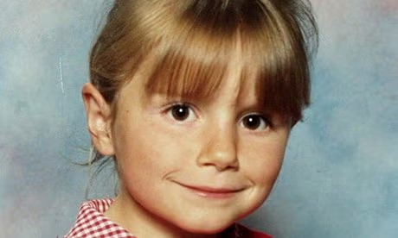
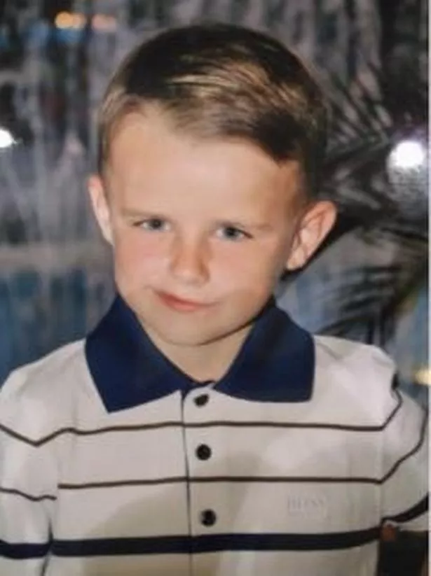
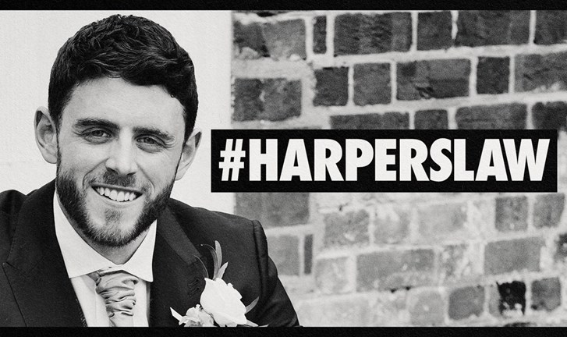
CRITERIA
Why did this campaign start?
What was the aim of the campaign? What did they want to achieve?
How did they do it? What methods were involved? i.e. TV interviews, petitions
Was the campaign successful? Has it changed law/policy/procedure? Did it raise awareness?

CAMPAIGNS
Sarah’s Law
Dignity in Dying
Snowdrop Campaign
Slow Down for Bobby
Harper’s Law

Campaign 1

Campaign 2

