
THE ASTLEY COOPER SCHOOL
Respect • Responsibility • Resilience

GCSE to A-level Summer Bridging Tasks 2026

A Level Biology

Name: ________________________________________

This pack contains a programme of activities and resources to prepare you to start A-level Biology in September. It is aimed to be used after you complete your GCSE
course, throughout the remainder of the summer term and over the summer holidays, to ensure you are ready to start your course in September.

This work should be brought to your first lesson and will help to show us your strengths and area’s for development.
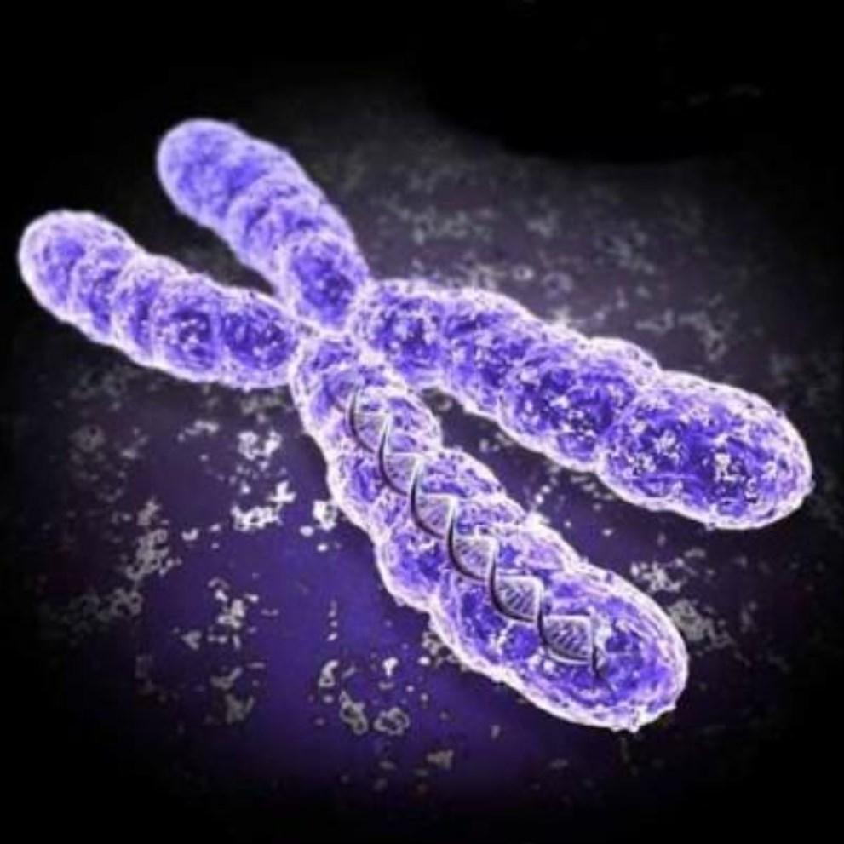

THE ASTLEY COOPER SCHOOL

Contents

Pg 3 Introduction to the course
Pg 4 Practicals
Pg 5 Course supplies
Pg 6-9 Task 1: Transition test
Pg 10-12 Task 2: Research task (Cornell notes)
Pg 13 Task 3: Scientific glossary
Pg 14-17 Task 4: Maths skills
Pg 18-19 Task 5: Project - Brine shrimp
Pg 20 Book recommendations
Pg 21 Movie suggestions
Pg 22 TED talks
Pg 23 Ideas for summer day trips

Tasks 1-5 are compulsory for you to complete during the summer and hand to your teacher during your first Biology lesson in September.

Pg 20-23 are optional activities if you like reading, watching films? TED talks or if you like going out on day trips.

Introduction

Congratulations on choosing one of the most interesting and challenging A-level course to study! You will have 4 hours of taught lessons a week. You will be expected to spend at least the same amount of time outside of lessons, completing home based learning, pre-reading, independent study, making notes to consolidate learning and reading around the subject.

You will be following the AQA 7401/2 A-level Biology course.

https://www.aqa.org.uk/subjects/science/as-and-a-level/biology-7401-7402/specification-at-a-glance

In year 12 you will study • Biological Molecules • Cells
• How organisms exchange substances with their environment • Genetic information and variation

In year 13 you will study

• Energy transfers in and between organisms

• Organisms respond to changes in the internal and external environments • Genetics, populations, evolution and ecosystems
• The control of gene expression

These topics will be taught through a variety of theoretical and practical lessons, and your progress will be assessed at regular intervals, providing you with feedback on your current level of attainment and how to improve your grade
Biology Field Course down by the sea

This year we propose to do a 3 day residential trip to Osmington Bay, Dorset to complete Ecology practical work and statistical analysis of the results. More details later in the year!

Practical work will be carried out throughout the year. You will be required to keep a lab book, and this will form part of the evidence for the Practical assessment. You will be awarded a pass or fail for your practical work, which will appear as a separate grade when you receive your A-level results. 15% of the questions on the final written exam papers will also be about practical work!

There are six required practicals in Year 12 and 6 in Year 13. However, you will complete far more than this.

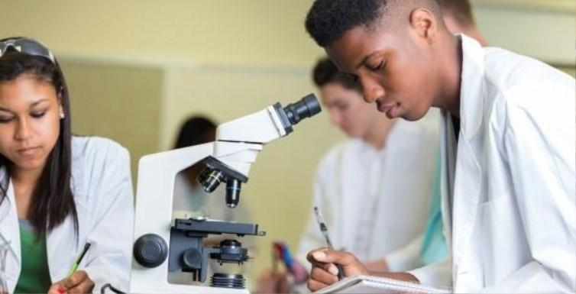
Maths also makes up approximately 10% of marks in the final exams. Some tasks involving key maths skills form part of this transition pack

What resources do I need?

Lab book - school will provide this
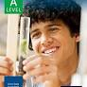
Textbooks - school will lend you one and you must return in good order at the end of the course

A4 ring binder – one of your choice to bring to lessons Dividers to go in the ring binder
Lever arch folder to keep all your biology notes in once topics are finished
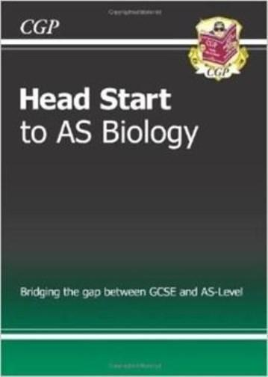
A4 lined paper Calculator
Ruler, pens, pencils

For those who can’t wait to get started why not buy Head start to AS Biology by CGP!!!
Transition Pack Tasks - to complete over summer

The following 40 minute test is designed to test your recall from your GCSE’s, analysis and evaluative skills and knowledge.
Remember to use your exam technique: look at the command words and the number of marks each question is worth. A suggested mark scheme is provided for you to check your answers.

1. a) What are the four base pairs found in DNA?

………………………………………………………………………………………………………………………………………………………………………. (2)

b) What does DNA code for?

………………………………………………………………………………………………………………………………………………………………………. (1)

c) Which organelle in a cell carries out this function?

………………………………………………………………………………………………………………………………………………………………………. (1)

2. a) What theory did Charles Darwin propose?

………………………………………………………………………………………………………………………………………………………………………. (1)

b) Why did many people not believe Darwin at the time?

………………………………………………………………………………………………………………………………………………………………………. (1)

c) Describe how fossils are formed.

……………………………………………………………………………………………………………………………………………………………………….

……………………………………………………………………………………………………………………………………………………………………….

………………………………………………………………………………………………………………………………………………………………………. (3)

d) The fossil record shows us that there have been some species that have formed and some that have become extinct.
i) What is meant by the term ‘species’?

………………………………………………………………………………………………………………………………………………………………………. (2)

ii) Describe how a new species may arise:

……………………………………………………………………………………………………………………………………………………………………….

……………………………………………………………………………………………………………………………………………………………………….

…………………………………………………………………………………………………………………………………………………………………(3)

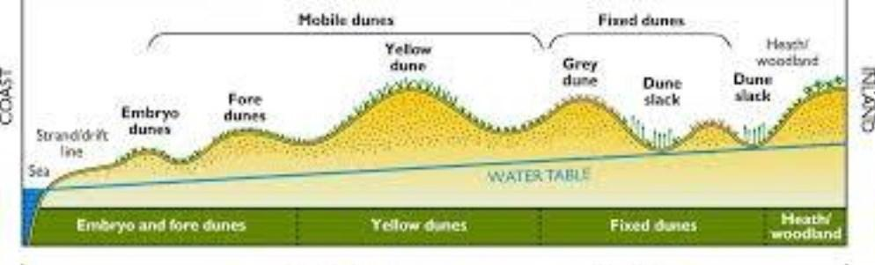
3. Ecologists regularly study habitats to measure the species present and the effect of any changes. One team of ecologists investigated the habitat shown in the picture below:

Image taken from http://www.macaulay.ac.uk/soilquality/Dune%20Succession.pdf

a) Define the following keywords: i) Population

…………………………………………………………………………………………………………………………………………………………………

ii) Community

………………………………………………………………………………………………………………………………………………………………… (2)

b) Give an example of one biotic factor and one abiotic factor that would be present in this habitat

Biotic: ………………………………………………………………………………………………………………………………………………………

Abiotic: ……………………………………………………………………………………………………………………………………………………… (2)
c) Describe how the ecologists would go about measuring the species present between the coast and the inland.

…………………………………………………………………………………………………………………………………………………………………

…………………………………………………………………………………………………………………………………………………………………

…………………………………………………………………………………………………………………………………………………………………

…………………………………………………………………………………………………………………………………………………………………

…………………………………………………………………………………………………………………………………………………………………

………………………………………………………………………………………………………………………………………………………………… (6)

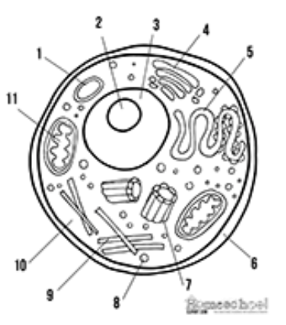
4. Every living organism is made of cells.

Image taken from http://prestigebux.com/worksheet/label-an-animal-cell-worksheet

a) Label the following parts of the animal cell:

2 ……………………………………………………………………………………………………………………………………………………………

5 ……..……………………………………………………………………………………………………………………………………………………

8 ………………………………………………………………………………………………………………………………………………………….. (3)
b) Describe how is the structure of the cell membrane related to its function?

…………………………………………………………………………………………………………………………………………………………………

…………………………………………………………………………………………………………………………………………………………………

………………………………………………………………………………………………………………………………………………………………… (3)

5. A medical research team investigated how quickly the body deals with glucose after a meal. They studied the blood glucose concentration of people who exercised versus those who did not.
Here are their results:

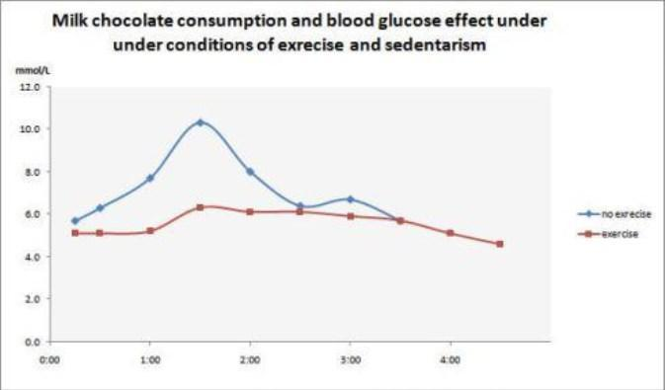
Hours after eating

Image taken from https://memoirsofanamnesic.wordpress.com/category/blood-glucose/

a) What organ in the body regulates blood glucose concentration?

………………………………………………………………………………………………………………………………………………………………… (1)
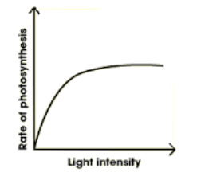
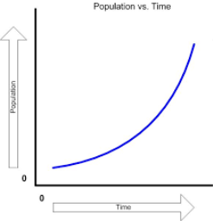
b) Explain how the stages that would bring about a return to normal blood glucose concentrations.

…………………………………………………………………………………………………………………………………………………………………

…………………………………………………………………………………………………………………………………………………………………

…………………………………………………………………………………………………………………………………………………………………

………………………………………………………………………………………………………………………………………………………………… (4)

c) Name one variable the researchers will have controlled.

………………………………………………………………………………………………………………………………………………………………… (1)

d) The researchers made the following conclusion:
“Blood glucose returns to normal values for all people after 4 hours” To what extent do you agree with this conclusion.

…………………………………………………………………………………………………………………………………………………………………

…………………………………………………………………………………………………………………………………………………………………

…………………………………………………………………………………………………………………………………………………………………

………………………………………………………………………………………………………………………………………………………………… (3)

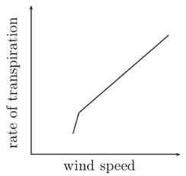
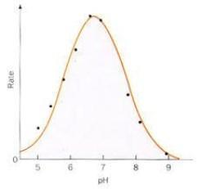
6. Scientists need to be able to interpret data in graphs to decide if there are trends in the results. For each graph bellow, describe the trend.

……………………………………………………………

……………………………………………………………
……………………………………………………………

……………………………………………………………(4)
Images taken from: http://www.everythingmaths.co.za/science/lifesciences/grade-10/05-support-and-transport-systems-in-plants/images/56aff2f9b6c5b041688f745ca928990c.png http://www.bbc.co.uk/staticarchive/afa3f2b16b4d58d077943c96929c9a4020fea83a.gif http://www.rpi.edu/dept/chem-eng/Biotech-Environ/Projects00/temph/enzyme.html
http://www.myearthwatchexperience.com/Essential%20Ecology.htm

Task 2: Research Activity

Research, reading and note making are essential skills for A level Biology study. For the following task you are going to produce ‘Cornell Notes’ to summarise your reading.

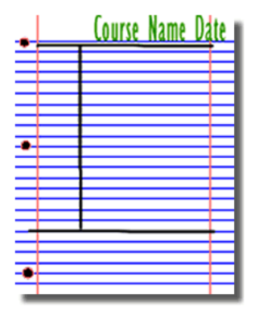
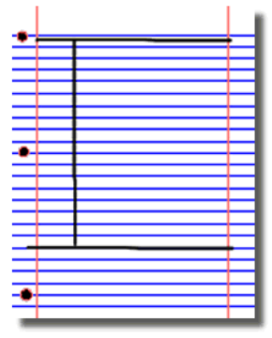
1. Divide your page into three sections like this

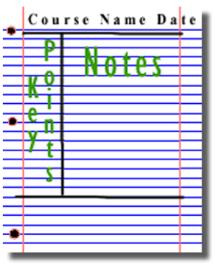

3. Use the large box to make notes. Leave a space between separate idea. Abbreviate where possible.
2. Write the name, date and topic at the top of the page

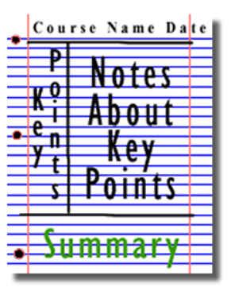
4. Review and identify the key points in the left hand box

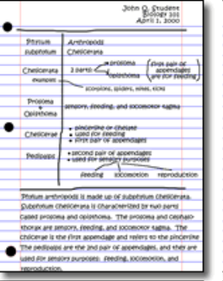

5. Write a summary of the main ideas in the bottom space

Images taken from http://coe.jmu.edu/learningtoolbox/cornellnotes.html

Instructions

In A-level Biology you will use your knowledge from GCSE and build on this to help you understand new and more demanding ideas. Complete the following tasks using the concept of Cornell notes to make sure your knowledge is up to date and you are ready to start studying:

Cells
The cell is a unifying concept in biology, you will come across it many times during your two years of A level study. Prokaryotic and eukaryotic cells can be distinguished on the basis of their structure and ultrastructure. In complex multicellular organisms cells are organised into tissues, tissues into organs and organs into systems. During the cell cycle genetic information is copied and passed to daughter cells. Daughter cells formed during mitosis have identical copies of genes while cells formed during meiosis are not genetically identical

Take a look at these videos: https://www.youtube.com/watch?v=gcTuQpuJyD8 https://www.youtube.com/watch?v=L0k-enzoeOM https://www.youtube.com/watch?v=qCLmR9-YY7o

Task:
Produce one page of revision notes to share with your class in September summarising one of the following topics: Cells and Cell Ultrastructure, Prokaryotes and Eukaryotes, or Mitosis and Meiosis.
Whichever topic you choose, your revision notes should include: Key words and definitions
Clearly labelled diagrams
Short explanations of key ideas or processes.

Biological Molecules
Biological molecules are often polymers and are based on a small number of chemical elements. In living organisms carbohydrates, proteins, lipids, inorganic ions and water all have important roles and functions related to their properties. DNA determines the structure of proteins, including enzymes. Enzymes catalyse the reactions that determine structures and functions from cellular to whole-organism level. Enzymes are proteins with a mechanism of action and other properties determined by their tertiary structure. ATP provides the immediate source of energy for biological processes.

Take a look at these videos: https://www.youtube.com/watch?v=H8WJ2KENlK0
http://ed.ted.com/lessons/activation-energy-kickstarting-chemical-reactions-vance-kite

Task:
Krabbe disease occurs when a person doesn’t have a certain enzyme in their body. The disease affects the nervous system. Produce one page of revision notes to share with your class in September summarising what an enzyme is.
It should include:
Describe the structure of an enzyme
Explain what enzymes do inside the body

DNA and the Genetic Code
In living organisms nucleic acids (DNA and RNA have important roles and functions related to their properties. The sequence of bases in the DNA molecule determines the structure of proteins, including enzymes.
The double helix and its four bases store the information that is passed from generation to generation. The sequence of the base pairs adenine, thymine, cytosine and guanine tell ribosomes in the cytoplasm how to construct amino acids into polypeptides and produce every characteristic we see. DNA can mutate leading to diseases including cancer and sometimes anomalies in the genetic code are passed from parents to babies in disease such as cystic fibrosis, or can be developed in unborn foetuses such as Downs Syndrome.
http://www.bbc.co.uk/education/guides/z36mmp3/revision

And take a look at these videos:
http://ed.ted.com/lessons/the-twisting-tale-of-dna-judith-hauck http://ed.ted.com/lessons/where-do-genes-come-from-carl-zimmer

Task:
Produce one page of revision notes to share with your class in September summarise the topic. You should use images, keywords and simple explanations to:
Define gene, chromosome, DNA and base pair
Describe the structure and function of DNA and RNA
Explain how DNA is copied in the body
Outline some of the problems that occur with DNA replication and what the consequences of this might be.

Exchange and Transport
Organisms need to exchange substances selectively with their environment and this takes place at exchange surfaces. Factors such as size or metabolic rate affect the requirements of organisms and this gives rise to adaptations such as specialised exchange surfaces and mass transport systems. Substances are exchanged by passive or active transport across exchange surfaces. The structure of the plasma membrane enables control of the passage of substances into and out of cells

Take a look at these videos:
http://ed.ted.com/lessons/insights-into-cell-membranes-via-dish-detergent-ethan-perlstein http://ed.ted.com/lessons/what-do-the-lungs-do-emma-bryce

Task:
Produce one page of revision notes to share with your class in September summarise the topic. Your notes should either: compare exchange surfaces in mammals and fish or compare exchange surfaces in the lungs and the intestines.
Your notes should:
Describe diffusion, osmosis and active transport
Explain why oxygen and glucose need to be absorbed and waste products removed. Compare and contrast your chosen focus.

Task 3: Scientific and investigative glossary of Scientific words

Scientific and Investigative Skills
As part of your A-level you will complete a practical assessment. This will require you to carry out a series of practical activities as well as planning how to do them, analysing the results and evaluating the methods. This will require you to: use appropriate apparatus to record a range of quantitative measurements (to include mass, time, volume, temperature, length and pH); use appropriate instrumentation to record quantitative measurements, such as a colorimeter or photometer; use laboratory glassware apparatus for a variety of experimental techniques, including serial dilutions; use of light microscopes at high power and low power, including use of a graticule; produce scientific drawing from observation with annotations; use qualitative reagents to identify biological molecules; separate biological compounds using thin layer/paper chromatography or electrophoresis; safely and ethically use organisms; use microbiological aseptic techniques, including the use of agar plates and broth; safely use instruments for dissection of an animal organ, or plant organ; and use sampling techniques in fieldwork.

Task:
Produce a glossary for the following key words:
accuracy, precision, anomaly, calibration, control group, control variable, dependent variable, independent variable, fair test, correlation, hypothesis, null hypothesis, probability, raw data, reliability, repeatability, reproducibility, random error, systematic error, true value, validity, zero error.

Task 4: Maths skills

Maths tasks should be completed and handed in during your first Biology lesson in September. Show workings in calculations to show how you got to your answer.

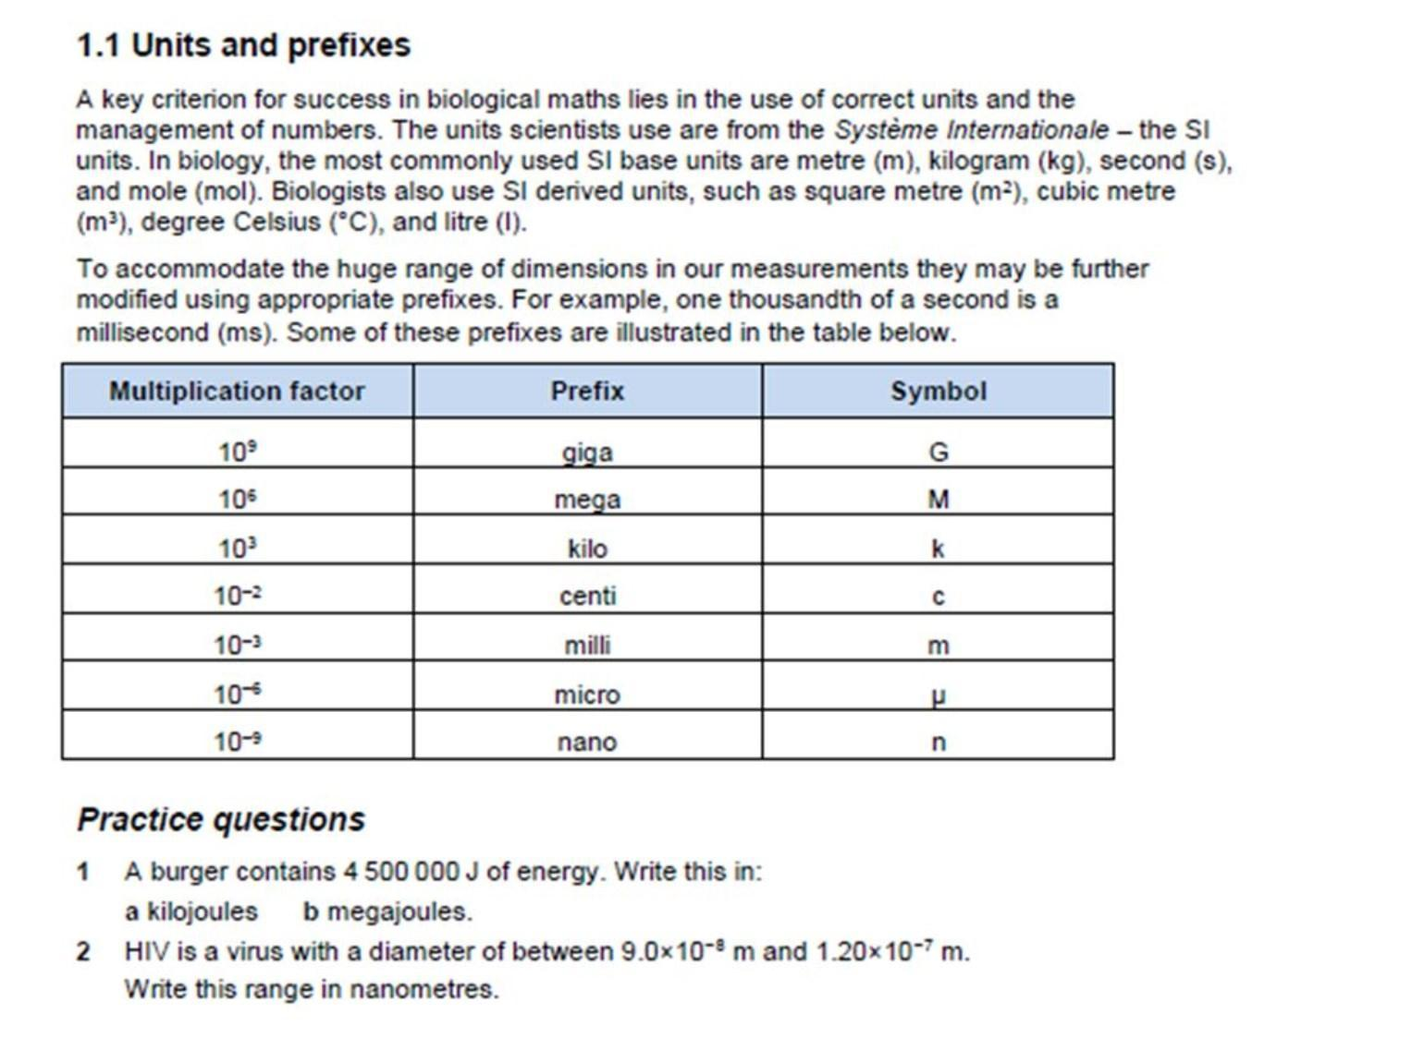

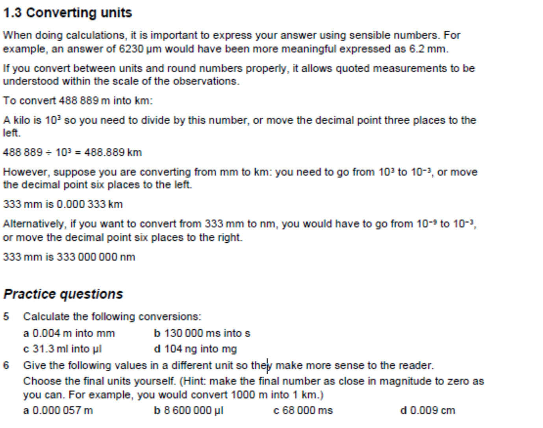

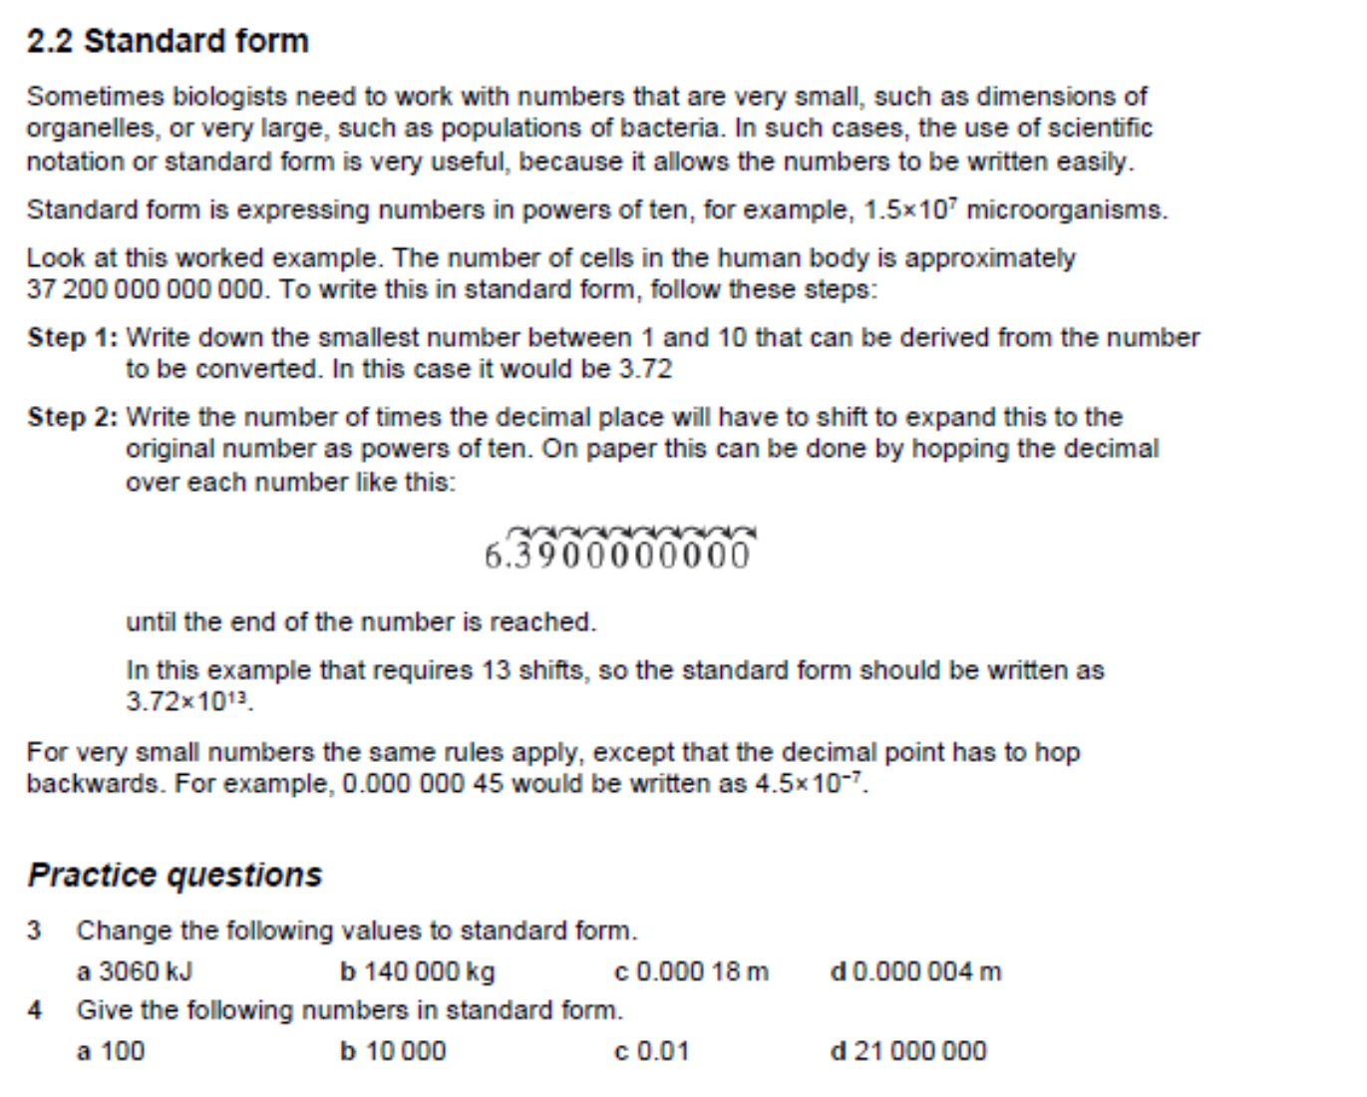

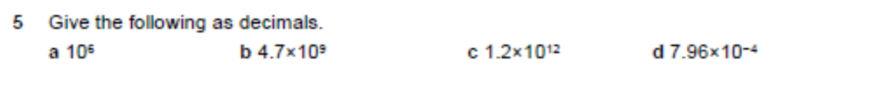

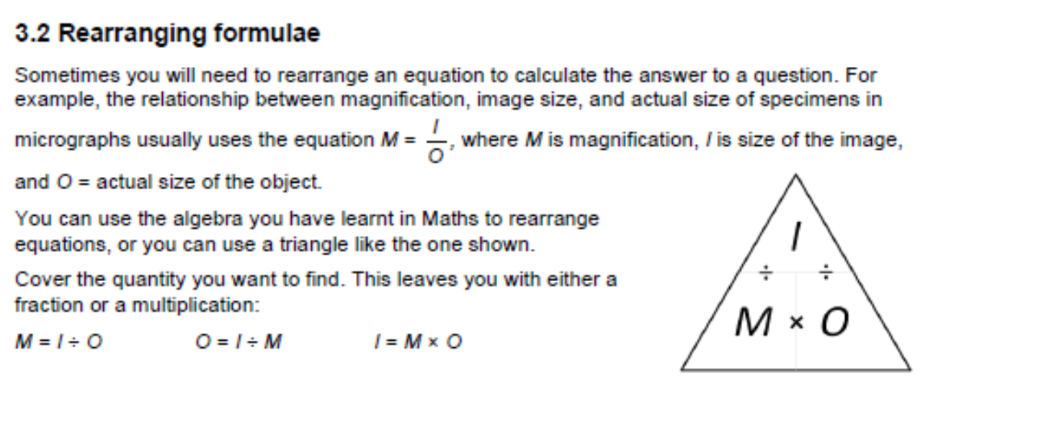

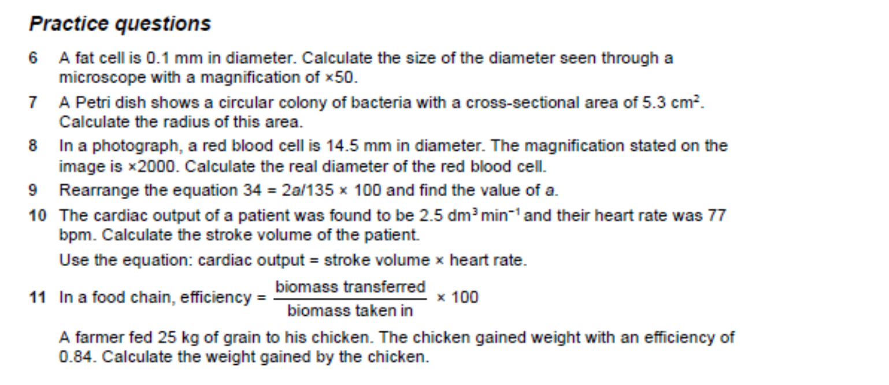

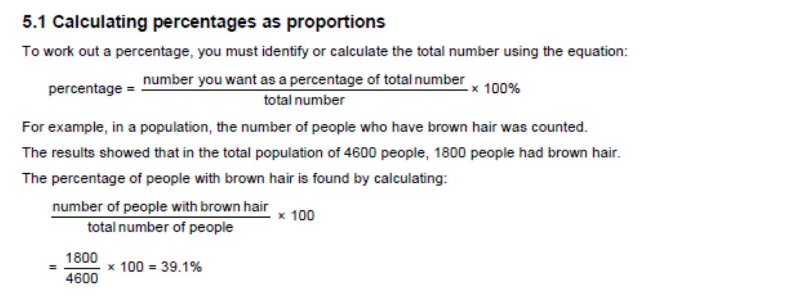

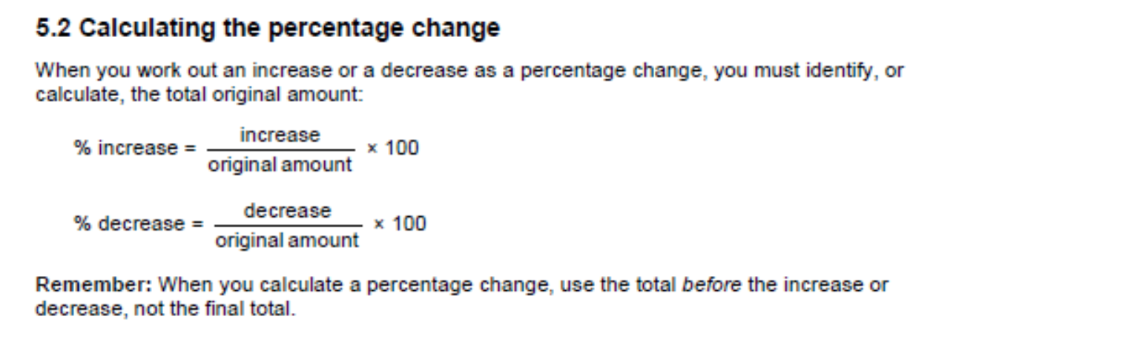
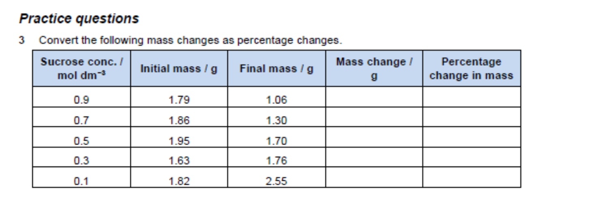
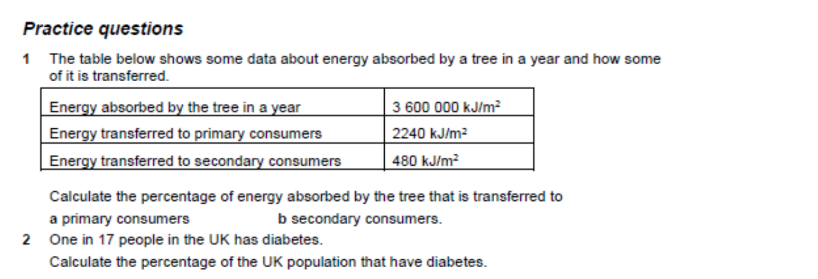

Task 5: Project

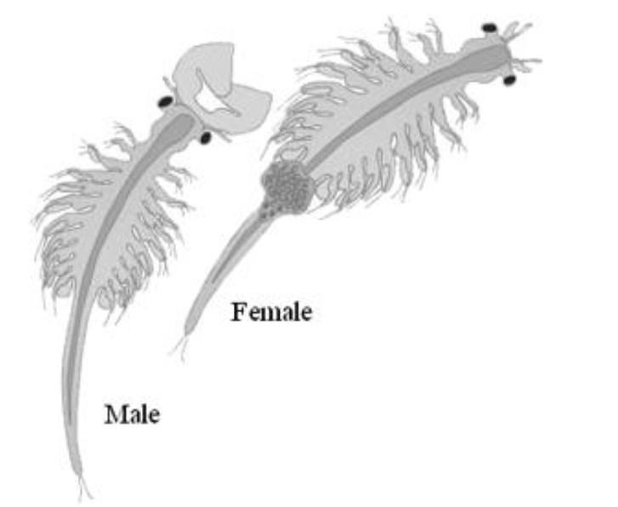
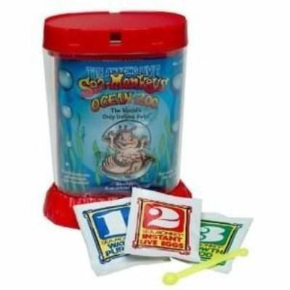
Brine Shrimp Artemia

Some of you may know these fab creatures as sea monkeys!!

Brine Shrimp are fascinating creatures that have changed little since the Triassic period. If you attended the Biology induction day earlier this year, you will have investigated these organisms by:

• Looking at samples in class.

• Making biological drawings of one from under the microscope. Is it male or female?
• Making observations about their movements.

You will be given more information on induction day about your summer research project

which makes up task 4 of your summer work. This part should not be started until after

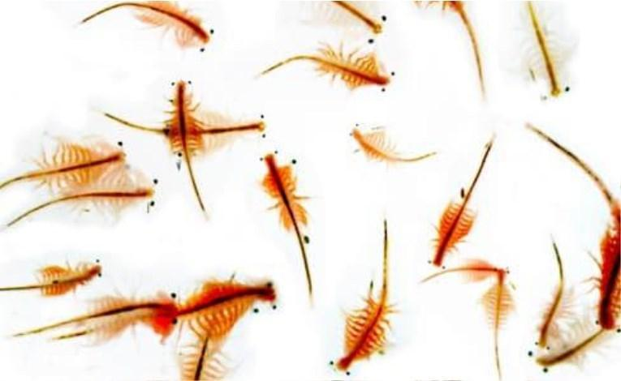
induction day, and incorporates different aspects of the A-level biology specification.
Your Summer Project!!

Brine shrimp Artemia are related to many areas of the the Yr 12 AS Biology Specification as shown below.

Produce a project that explains each of the curriculum links below.

Hand it in to your Biology Teacher in your first lesson in September.
1. Brine Shrimp live in water. Explain why water is such a biologically significant molecule? What are the chemical properties of water
that are important in biology?

( AQA 3.1.7 Water)

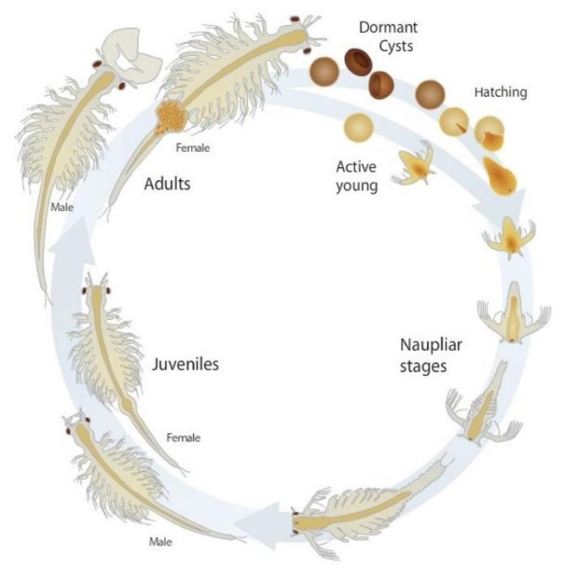
3. Describe the adaptations of Brine Shrimps that have enabled them to survive successfully since the Triassic period.

(AQA 3.4.4 Genetic diversity &

adaptation)

5. Artemia is a genus of aquatic crustaceans. How is the phylogenetic classification system organised?
(AQA 3.4.5 Species & Taxonomy)


Why not try setting up your own Brine shrimp ecosystem over the summer? They are available commercially as Sea Monkeys or Aqua Dragons and small sets can be bought in most toy shops!!

Keep a photo diary to show us!

2. All life on Earth exists as cells. Name and explain the functions of all structures in a Eukaryotic cell.

(AQA 3.2.1.1 Structure of Eukaryotic Cells)

4. Brine shrimp live in salty water (hence the name brine!!) How do they control their osmotic regulation?

(AQA 3.2.3 Transport across cell membranes.

What else? Having a good biological general knowledge is vital for success on the A-level course. This involves reading around the subject. Can you add any additional information which you found interesting about brine shrimps?


Book recommendations

Kick back this summer with a good read. The books below are all popular science books and great for extending your understanding of Biology
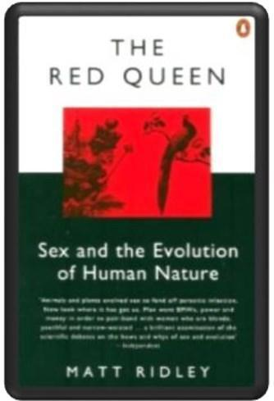
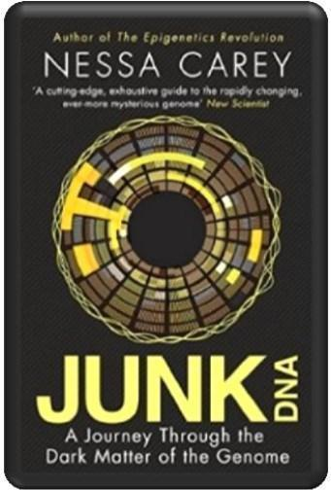

The Red Queen
It's all about sex. Or sexual selection at least. This book will really help your understanding of evolution and particularly the fascinating role of sex in evolution. Available at amazon.co.uk

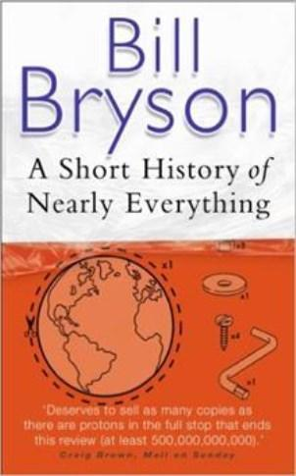

Junk DNA
Our DNA is so much more complex than you probably realise, this book will really deepen your understanding of all the work you will do on Genetics. Available at amazon.co.uk

A Short History of Nearly Everything
A whistle-stop tour through many aspects of history from the Big Bang to now. This is a really accessible read that will re-familiarise you with common concepts and introduce you to some of the more colourful characters from the history of science! Available at amazon.co.uk



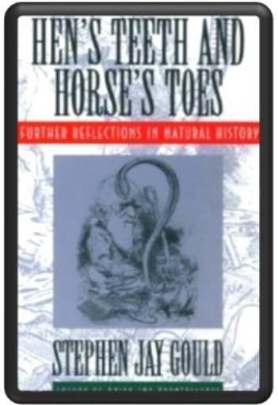

Studying Geography as well? Hen’s teeth and horses toes Stephen Jay Gould is a great Evolution writer and this book discusses lots of fascinating stories about Geology and evolution. Available at amazon.co.uk

An easy read.. Frankenstein’s cat
Discover how glow in the dark fish are made and more great Biotechnology breakthroughs. Available at amazon.co.uk



Everyone loves a good story and everyone loves some great science. Here are some of the picks of the best films based on real life scientists and discoveries. You won't find Jurassic Park on this list, we’ve looked back over the last 50 years to give you our top 5 films you might not have seen before. Great watching for a rainy day.
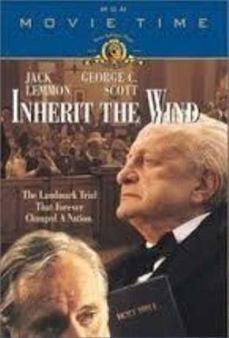



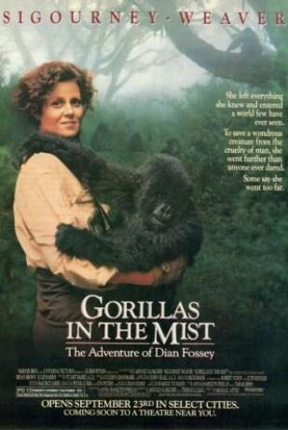
Gorillas in the Mist (1988) An absolute classic that retells the true story of the life and work of Dian Fossey and her work studying and protecting mountain gorillas from poachers and habitat loss. A tear jerker.

Inherit The Wind (1960) Great if you can find it. Based on a real life trial of a teacher accused of the crime of teaching Darwinian evolution in school in America. Does the debate rumble on today?


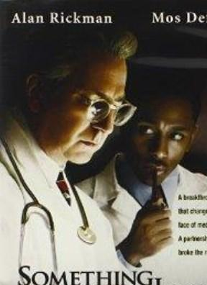
Lorenzo’s Oil (1992) Based on a true story. A young child suffers from an autoimmune disease. The parents research and challenge doctors to develop a new cure for his disease.

Andromeda Strain (1971) Science fiction by the great thriller writer Michael Cricthon (he of Jurassic Park fame). Humans begin dying when an alien microbe arrives on Earth.

Something the Lord Made (2004)
Professor Snape (the late great Alan Rickman) in a very different role. The film tells the story of the scientists at the cutting edge of early heart surgery as well as issues surrounding racism at the time.

There are some great TV series and box sets available too, you might want to check out: Blue Planet, Planet Earth, The Ascent of Man, Catastrophe, Frozen Planet, Life Story, The Hunt and Monsoon.
TED talks
If you have 30 minutes to spare, here are some great presentations (and free!) from world leading scientists and researchers on a variety of topics. They provide some interesting answers and ask some thought-provoking questions. Use the link or scan the QR code to view:
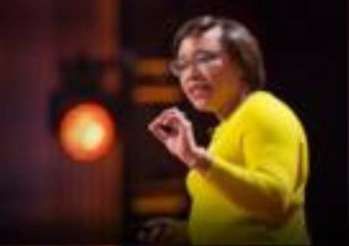

A New Superweapon in the Fight Against Cancer
Available at : http://www.ted.com/talks/paula_hammon d_a_new_superweapon_in_the_fight_agai nst_cancer?language=en
Cancer is a very clever, adaptable disease. To defeat it, says medical researcher and educator Paula Hammond, we need a new and powerful mode of attack.


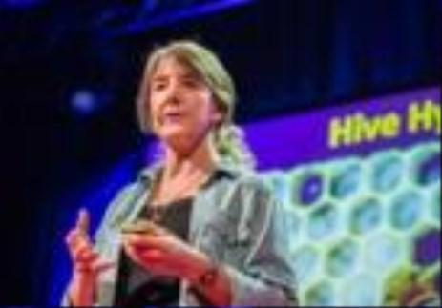

Why Bees are Disappearing Available at :
http://www.ted.com/talks/marla_spivak_ why_bees_are_disappearing?language=en Honeybees have thrived for 50 million years, each colony 40 to 50,000 individuals coordinated in amazing harmony. So why, seven years ago, did colonies start dying en-masse?


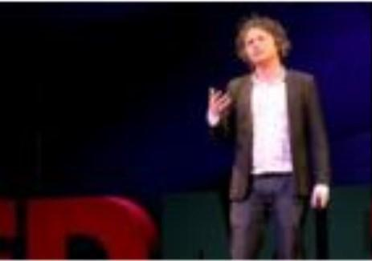
Why Doctors Don’t Know About the Drugs They Prescribe
Available at : http://www.ted.com/talks/ben_goldacre_ what_doctors_don_t_know_about_the_dr ugs_they_prescribe?language=en
When a new drug gets tested, the results of the trials should be published for the rest of the medical world — except much of the time, negative or inconclusive findings go unreported, leaving doctors and researchers in the dark.

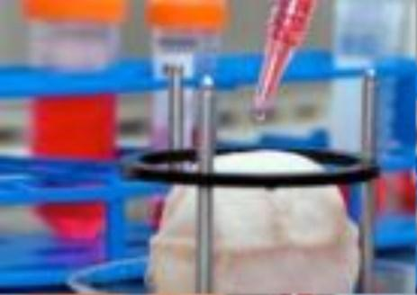

Growing New Organs Available at :
http://www.ted.com/talks/anthony_atala_ growing_organs_engineering_tissue?langu age=en
Anthony Atalla's state-of-the-art lab grows human organs — from muscles to blood vessels to bladders, and more.


If you are on holiday in the UK, or on a staycation at home, why not plan a day trip to one of these :

Glasgow Science Centre - Glasgow

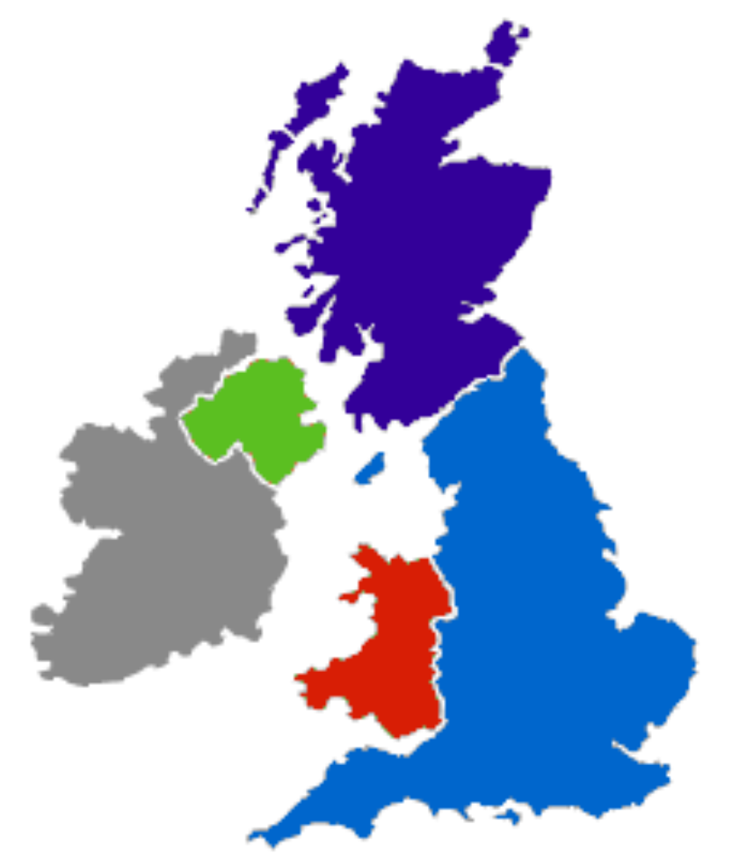
The Lakeland Wildlife Oasis - Milnthorpe

W5 - Belfast

Anglesey Sea Zoo -Anglesey

Think-tank -Birmingham

National Museum -Cardiff

The Eden Project -Cornwall

Bristol Science Centre - Bristol

The Living Rainforest
- Newbury
Oxford University Museum of Natural History - Oxford

Dundee Science Centre - Dundee

Scottish Seabird centre – North Berwick

Life – Newcastle-upon-Tyne

Cambridge Science Centre - Cambridge

Herriman Museum and Gardens - Londo

Centre of the Cell -London

Royal Botanic Gardens – Kew -Edinburgh

National Marine Aquarium - Plymouth

