Year 11-12 Economics Transition homework
Every student taking economics at AS-level in 2024-25 will submit a transition
project.The aim is to help you to start developing the independent work skills and some of the economics specialist skills you will be using throughout A-level and beyond. It will also introduce you to some of the key topics we will cover and help you to get a head start in your learning.
Perhaps the most important aspect of the project is that it encourages you to ‘be an economist’ and not just an ‘economics student’.
Name: ______________________________________

Part A | What is economics?
Part B | Applying Economics to the real world – Supply and Demand: An A level question
Part C | Investigation Globalisation, international trade and Donald Trump’s trade war.
Part D | Online transition exercise from Tutor2u:  https://www.tutor2u.net/economics/collections/head-start-for-alevel economics-transition-resource-year-11-students

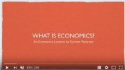

Part A – What is economics?
Watch the video introduction to Economics:
https://www.youtube.com/watch?v=2YULdjmg3o0

Please use the internet to conduct research for the following questions.

- Summarise the key points of what economics is
[type your answer here]

- What is meant by free market economics?
[type your answer here]

- What is positive economics? What is normative economics?
[type your answer here]

Part B: Microeconomics
Supply and Demand
In Theme 1, you will learn about the key economic concepts of supply and demand. You need a good understanding of:
• What we mean by supply and demand?
• What factors impact the supply and demand of certain goods?
• What is the relationship between changing supply and demand, and the price of a product?
Demand
What do we mean by ‘demand’?
[type your answer here]
What are the factors that can influence the demand for a good or service? Explain why they have an impact.
[type your answer here]
Supply
What do we mean by ‘supply’?
[type your answer here]

What are the factors that can influence the demand for a good or service? Explain why they have an impact.
[type your answer here]

What is the relationship between demand, supply and prices?
[type your answer here]

Applying Economics to real world case studies
Read the extract below on the housing market and answer the questions in the spaces provided
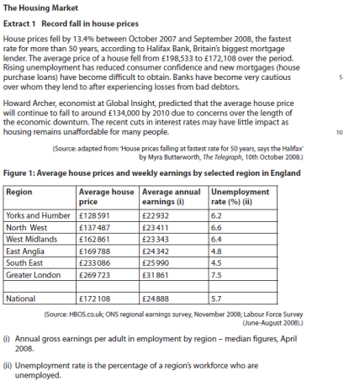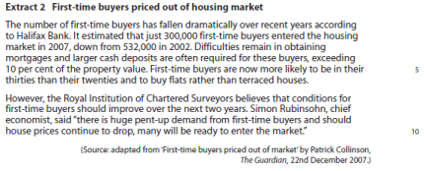
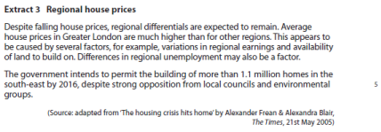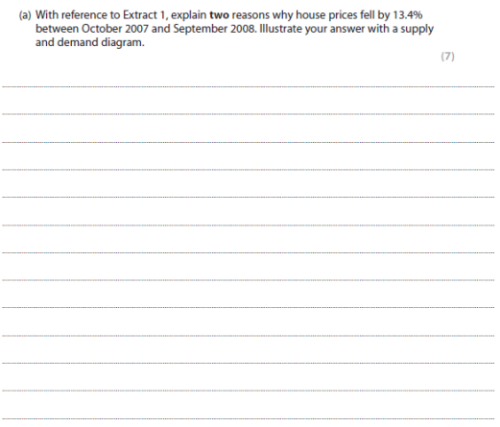
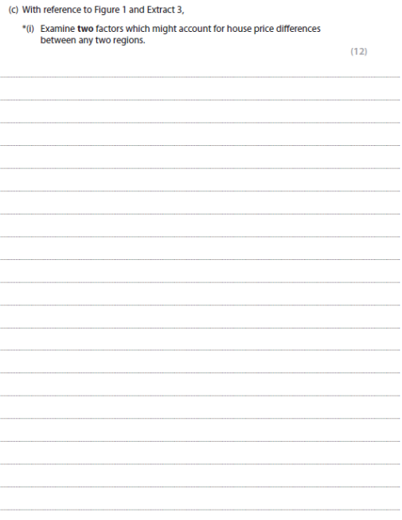

Part C - Short questions and trade investigation
Q1
The table below shows the level of unemployment in the UK economy.
Year | Unemployment (millions)
2010 | 13
2011 | 5
2012 | 8
2013 | 11
2104 | 18
2015 | 11
2016 | 6

Calculate the following statistics for the number of leaves affected by the holly leaf miner:
Mean
Median
Mode

Q2
 | 2012 | 2013 | 2014 | 2015 | 2016
Income after tax break (£) | 13,000 | 12,000 | 10,000 | 10,100 | 10,400
Income before tax break (£) | 10,000 | 10,000 | 9,000 | 7,000 | 7,300

The table shows the average income of UK residents from 2012-2016. Complete this table of results
for 2013-2016

2012 | 2013 | 2014 | 2015 | 2016
13,000 – 10,000 = 3,000
% change in income = 30%

Q3
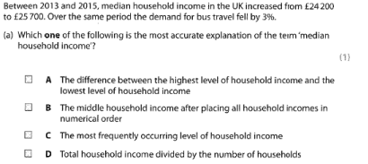Q4
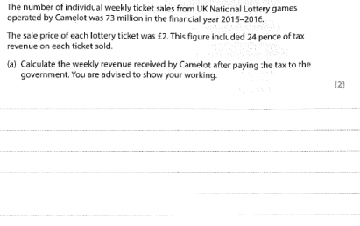
Q5
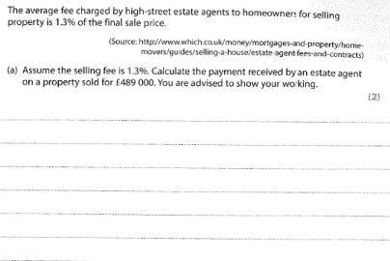Q6
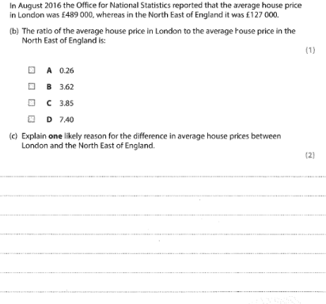

RESEARCH TASK: INTERNATIONAL TRADE, DONALD TRUMP, TRADE WARS & PROTECTIONISM
READ THE ARTICLE FROM THE BBC WEBSITE ON DONALD TRUMP’S TRADE POLICY AND THEN ANSWER THE QUESTIONS BELOW.

Investigation: Globalisation, trade and Donald Trump!
US President Donald Trump has slapped steep tariffs (taxes) on billions of dollars' worth of Chinese goods, ranging from dishwashers to aircraft tyres. China has long threatened to respond to such a move, and it quickly announced its own tariffs on $35bn (£26bn) worth of US goods. This puts the world's two largest economies at each other's throats. But what is a trade war? How does protectionism work? And how will it all affect you

What is a trade war?
It's what it sounds like - a trade war is when countries try to attack each other's trade with taxes called tariffs and physical limits on imports - quotas. One country will raise tariffs, a type of tax, causing the other to respond, in a tit-for-tat escalation. This can hurt other nations' economies and lead to rising political tensions between them. US President Donald Trump reckons trade wars are "good" and easy. He's not afraid to raise tariffs.

But what is a tariff?
It's a tax on a product made abroad. In theory, taxing items coming into the country means people are less likely to buy them as they become more expensive. The intention is that they buy cheaper local products instead - boosting your country's economy.

Why is Trump doing this?
The president has imposed 25% tariffs on $50bn worth of Chinese goods, accusing Beijing of stealing intellectual property - which means designs and product ideas. Mr Trump also wants to cut the trade deficit with China - a country he has accused of unfair trade practices since before he became president. Mr Trump often made a big point about cutting the country's trade deficits. He's convinced it hurts US manufacturing, and has said time and time again on the stump and on Twitter that the US must do more to tackle them.

What's a trade deficit?
It's a term meaning the difference between how much your country buys from another country, compared with how much you sell to that country. And the US has a massive trade deficit with China. Last year, it stood at about $375bn. Mr Trump's not happy about that
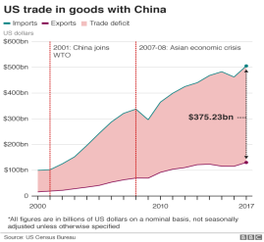

He wants to cut back this trade deficit, and he intends to use tariffs to do it. But while the president hates them, trade deficits are not necessarily a bad thing. Many wealthier countries have in recent decades shifted from manufacturing economies to service economies. The US exported $242.7bn worth of services in 2017, in areas like banking, travel and tourism. Services account for 90% of the US economy. China, in contrast, doesn't export nearly as many services as it does manufactured goods. So the president's obsession with trade deficits is not always popular, with critics damning the administration's moves as protectionism.

What's protectionism?
Protectionism is trying to use tariffs to boost your country's industry, and shield it from foreign competition. Take Mr Trump's steel and aluminium tariffs. At the start of March, before his latest moves against China, the president announced a 25% tariff on all steel imports, and 10% on aluminium. The Trump administration claims the US relies too much on other countries for its metals, and that it couldn't make enough weapons or vehicles using its own industry if a war broke out. Critics point out the US gets most of its steel from Canada and the EU - major US allies.

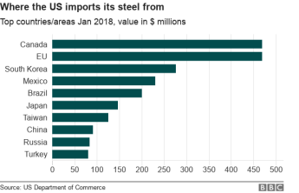

In theory, taxing foreign steel and aluminium will mean US companies will buy local steel instead.
The thinking is that will boost the US steel and aluminium industries, as more companies will want to buy their goods. Steel and aluminium prices will go up in the US because there will be less of these goods coming in from abroad - so the greater demand for local steel will push up the price, lifting profits for steel makers.

But does it work?
Maybe… US steel makers could get a boost - demand will drive new hires and bigger profits.
But the US companies that need raw materials, like car and aeroplane makers, will see their costs rise.
That means they might have to put up the prices on their finished products. That would hurt consumers.
So car prices could go up in the US. As could prices for gadgets, plane tickets and even beer - the price of making a can could rise. Beer cans could become more pricey - and that cost could be pushed onto

How could tariffs affect me?
They could affect people around the world - especially since China has retaliated. The world's second-largest economy has taxed US agricultural and industrial products, from soybeans, pork and cotton to aeroplanes, cars and steel pipes. In theory, China could also tax US tech companies like Apple. That would hit the tech giant, and it could be forced to raise its prices to compensate. A global trade war could hurt consumers around the world by making it harder for all companies to operate, forcing them to push higher prices onto their customers.

Is free trade better then?
Depends who you ask. Free trade is the opposite of protectionism - it means as few tariffs as possible, giving people the freedom to buy cheaper or better-made products from anywhere in the world.
This is great for companies trying to cut costs, and that's helped drive prices down and boost the world economy.st expansion of shipping and transfer of goods around the world. Cars, smart phones, food, flowers - free trade has brought affordable products from around the world to your home. But at the same time, that means companies are less likely to buy local products. Why buy domestic when you can get more, cheaper, from a different country? This means the loss of jobs in wealthier countries, and uneven growth - while free trade has made some people richer, it's made others poorer.

How is it all going to end?
No idea. Historians have pointed out that tariffs often lead to higher costs for the consumer, while economists across the board are against the plans. The Republican Party is also overwhelmingly against Mr Trump on tariffs - they're big supporters of free trade. Mr Trump's decision to take on China could lead to adverse effects for consumers in the US and in China, but also worldwide. An economic showdown between the world's biggest economies doesn't look good for anyone.

Define ‘international trade’
[type your answer here]

Define tariffs and quotas.
[type your answer here]

Define protectionism
[type your answer here]

Donald trump has imposed tariffs on imports of Steel and Aluminium from China, the EU, Mexico and Canada. Can you explain his reasons?

Explain 3 groups likely to benefit from the tariffs.
[type your answer here]

Explain 3 groups likely to benefit from the tariffs.
[type your answer here]

Explain 3 groups likely to be hurt by the tariffs.
[type your answer here]

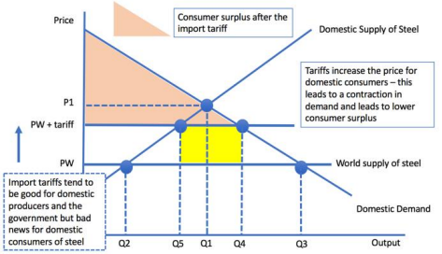
A LEVEL DIAGRAM ANALYSIS: THE IMPACT OF A TARIFF
The diagram above is a new Supply and Demand analysis which shows you the impact of a tariff on Steel imports. Try to write an explanation of the diagram by reading it closely. In your explanation, try to answer the following questions by explaining and annotating the diagram:
- What happens to the amount of imports received once the tariff is brought in? Can you see this on the diagram?
- What happens to the price of Steel for consumers?
- What do you think the term ‘consumer surplus’ means – look it up! What does the tariff do to consumer surplus – reduce it or increase it?
- How much money does the Government raise in tariff revenue/ Where can you find this on the diagram?
- Is the Tariff good for the US’s own domestic Steel producers – can you see the effect on the diagram?
- Overall – do you think this diagram suggests that tariffs are a good or a bad idea for the world economy as a whole – explain your answer!

Part D: Online lessons from Tutor 2u – Head Start in Economics
https://www.tutor2u.net/economics/collections/head-start-for alevel-economics-transition-resource-year-11-students
Use the link above to go to the Tutor2u website and complete a series of interactive lessons which include an introduction to Macroeconomics as well as a special series on the economics of the Coronavirus. Watch all the videos listed below and complete the worksheets & quizzes, write your answers in your self-quizzing books and label each lesson.
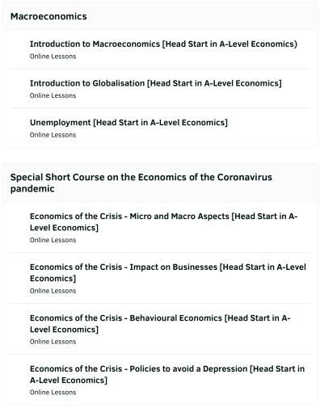

Give at least two different responses to each task:
1. Things you NEED (must have) to survive
a. | b. | c.

2. Natural Resources found in the UK that are RENEWABLE
a. | b. | c.

3. Natural Resources found in the UK that are FINITE
a. | b. | c.

4. Resources which can be RECYCLED
a. | b. | c.

5. Resources Britain has to buy from other countries
a. | b. | c.

6. Factors which would influence your decision whether to buy something or not
a. | b. | c.

7. Reasons why coffee is more expensive than tea
a. | b. | c.

8. Things the Government makes you do
a. | b. | c.

9. Things the Government prevents you from doing
a. | b. | c.

10. Goods or services the Government provides for us
a. | b. | c.

11. Factors that affect your Standard of Living
a. | b. | c.

12. Different foreign currencies and an example of a country that uses each one
a. | b. | c.
a. | b. | c.

Types of tax either people or businesses pay
a. | b. | c.

13. Reasons why some people are unemployed
a. | b. | c.

14. Ways the government helps people get jobs
a. | b. | c.

15. Goods or services Britain exports (sells to other countries)
a. | b. | c.

16. Ways in which being in the EU affects us
a. | b. | c.

17. Why prices rise
a. | b. | c.

18. Influences over people’s willingness to borrow money/buy on credit
a. | b. | c.

19. Reasons Britain has begun to come out of recession recently
a. | b. | c.

20. Reasons why people go out to work
a. | b. | c.

You are now going to research a business and create a written report to show how they are affected by the local and national economy. Use the points provided below as a guide. You will need to reference any sources that you use.
Write a brief history of the business and how they have become successful.
Identify the stakeholders (including customers, competitors, the government, and the local community) of the business and explain how they are affected by the business.
Explain the sources of finance that the business might have used since it was established (e.g. a bank loan to buy equipment or a mortgage to buy a building).

Explain the following and their impact on your chosen business and their customers:
∙ Interest rates
∙ Exchange rates
∙ Inflation

