A Level Media Studies

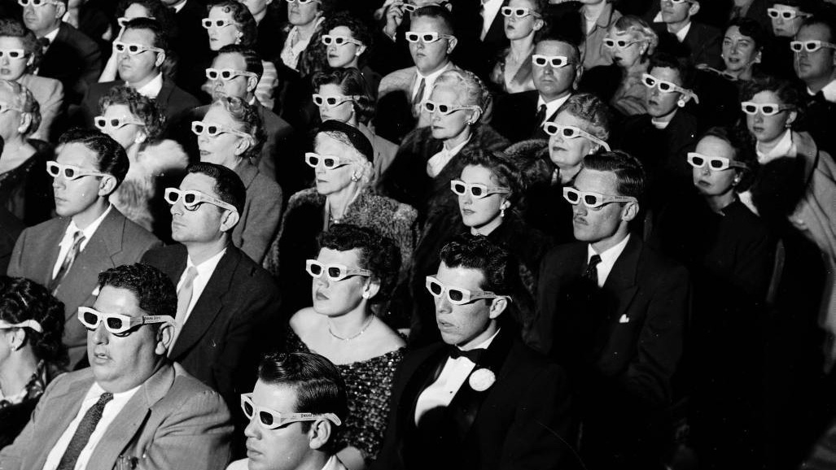
New Year 12 Summer Introduction workbook

This booklet is for you to start exploring the world of Media Studies. Hopefully you will have a bit of fun doing these tasks as they are meant to help you start to explore the key areas that we study in Media Studies.
DON’T WORRY if you aren’t sure of anything or if you find any of the tasks a bit tricky! Media Studies A Level is an entirely new subject for you so there may be bits that seem new and strange! Miss Smith and Mrs Wiles’ advice to you as our new Media Students is:
‘Give it your best shot and have fun exploring the Media!’

Week 1:
Welcome to Media Studies!
We are looking forward to starting our lessons in year 12! This booklet will help you to start building your media skills and your knowledge of media texts.

In Media Studies we explore four key areas:
MEDIA LANGUAGE
REPRESENTATION
MEDIA INDUSTRIES
MEDIA AUDIENCES

When you study A Level media you will explore the following areas:
TV
MUSIC
MAGAZINES
RADIO
VIDEO GAMING / ON LINE SOCIAL MEDIA
NEWSPAPERS
ADVERTISING & MARKETING
FILM

MEDIA LANGUAGE

DEFINITION: The way in which the meaning of a media text is communicated to the audience through signs and codes

You already have a head start in analysis as a Media student because you have grown up surrounded by media texts, so you have already been subconsciously analysing media language for years!
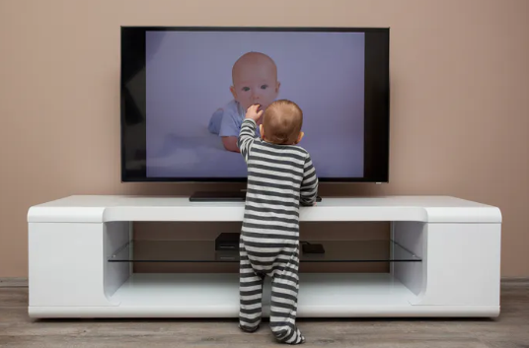

TASK 1 – WHAT DO YOU ALREADY KNOW?
Match the genre to the film posters. Whilst you are doing it think about HOW you know what type of film it is just from looking at the poster.
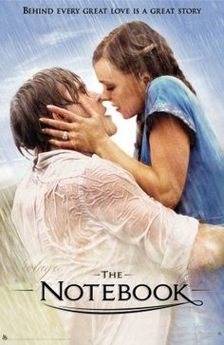
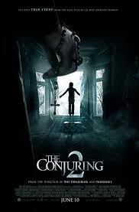
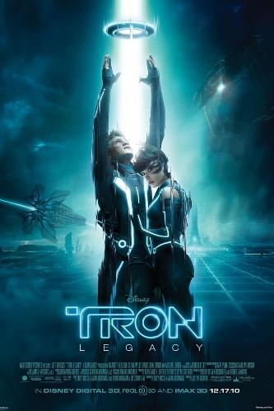
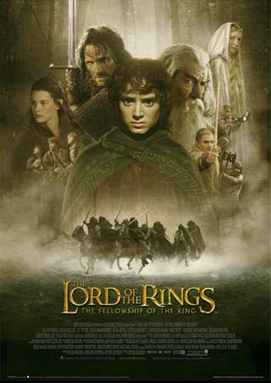

Horror
Romance
Sci Fi
Fantasy/Adventure

Task 2
Choose ONE of the posters from the previous task and explore how you knew what genre it was.
Fill in the boxes with your thoughts

Film Title…………………………………………..

Genre…………………………………………………….
What did the COLOURS in the poster tell me about the genre?
……………………………………………………………………………………………………………………………………………………………………………………………………………………………………………………………………………………………………………………………………………………………………………………………………………

What did the IMAGES in the poster tell me about the genre?
……………………………………………………………………………………………………………………………………………………………………………………………………………………………………………………………………………………………………………………………………………………………………………………………………………

What did the LAYOUT of the poster tell me about the STORY AND CHARACTERS?
……………………………………………………………………………………………………………………………………………………………………………………………………………………………………………………………………………………………………………………………………………………………………………………………………………

Representation

Week 2:
TASK 3: Using your knowledge of visual signifiers of genre create your own film poster.
Either construct it on computer or draw it by hand
Film Genre:
Film Title:
Main image/s:
Colours:
Font:

In Media Studies we look at how the media presents certain things like:
People
Issues
Events
The way these things are presented in media texts can depend on factors like, the political leanings of the producers, the audience and the time in which the text was produced.

HISTORY HIT!
During the Second World War many women took on traditionally ‘male roles’ whilst men were fighting.
After the war through the 1950’s and into the 1960’s, society was keen to return to pre-war gender roles with women encouraged to ‘return to the home’ and their traditional family roles as wife, mother and homemaker.
This stereotypically feminine role of women as weaker, childlike, nurturing and needing a man was reflected in representations in media texts of the time like advertising and magazines
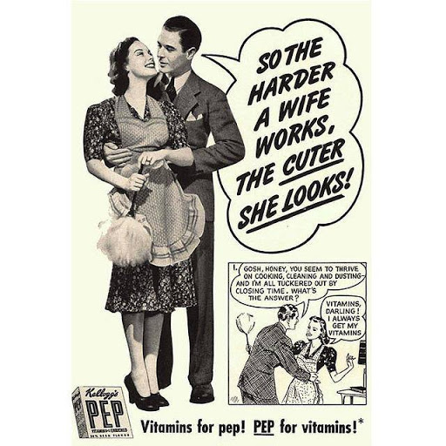
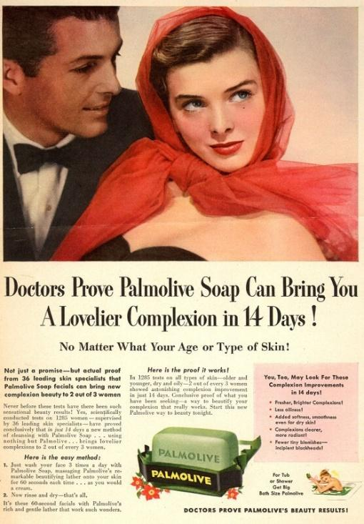
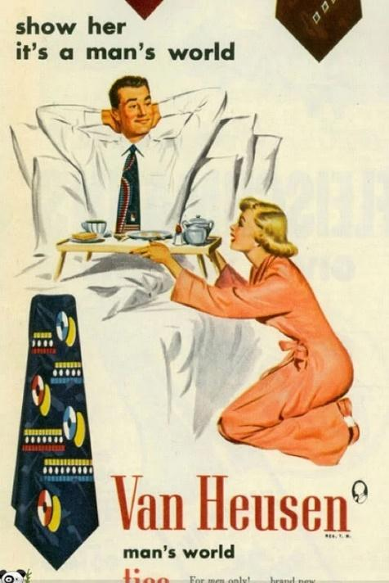
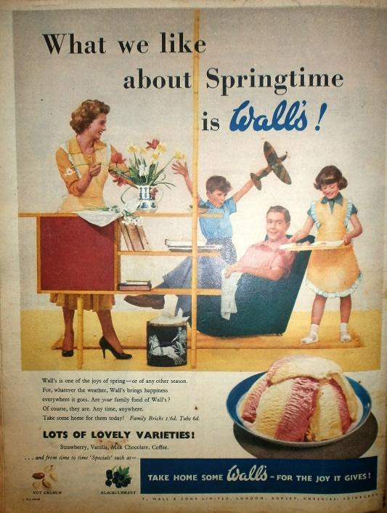
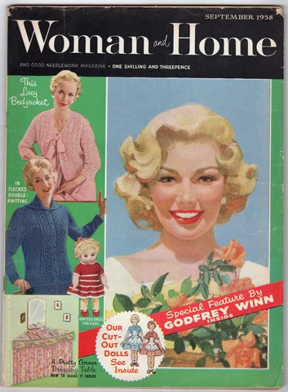
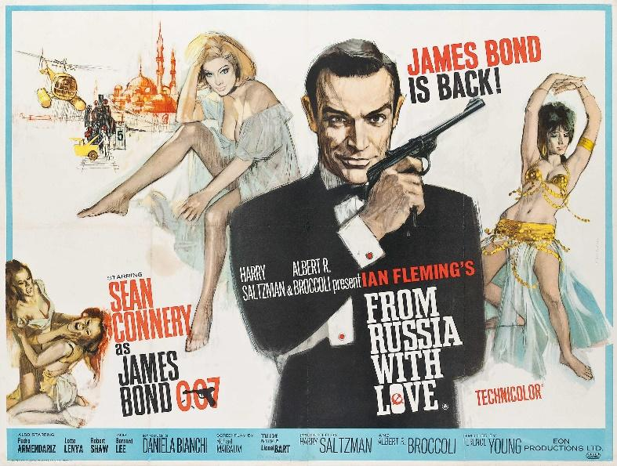

Week 3:
TASK 4: Look at these media texts from the 1950’s and 60’s.
Highlight the words in the boxes that best describe how men and women were represented. If you don’t understand any of the words, look them up.

WOMEN: Highlight the words that you think best sum up how women were represented in Media texts in the 1950’s/60’s
SUBMISSIVE DOMINANT MOTHERS
WIVES CAREER WOMEN PRETTY
NURTURING THIN INDEPENDENT
PERFECT COMPLICATED SIMPLE
ETHNICALLY DIVERSE WHITE

MEN: Highlight the words that you think best sum up how men were represented in Media texts in the 1950’s/60’s
STRONG DOMINANT WEAK SIMPLE
SMART PROFESSIONAL SCARED
IN CONTROL HOMEMAKERS HANDSOME
NURTURING PROVIDERS PROTECTORS
CLEAN CUT ETHNICALLY DIVERSE WHITE

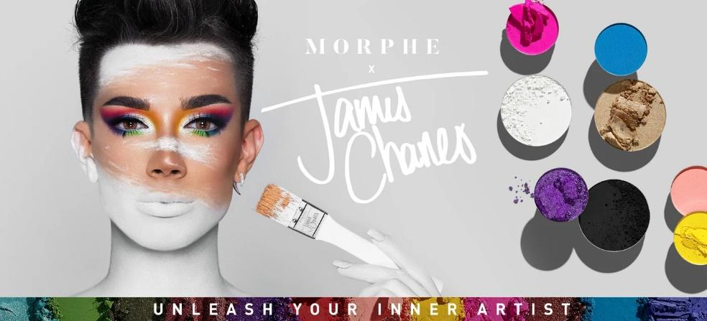
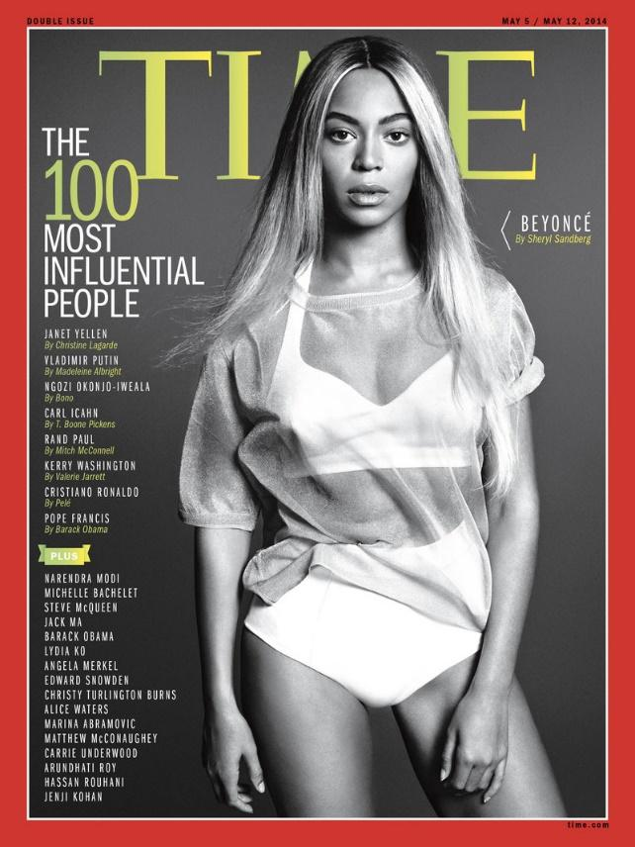
Times change and that means that the way the media represents things change.
TASK 5: Look at these representations of men and women in contemporary (modern) media texts and write a short paragraph about how you think representations of men and women have changed since the 1950’s
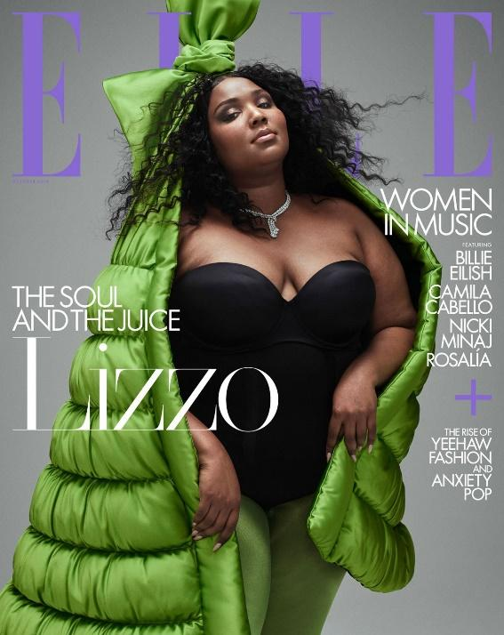
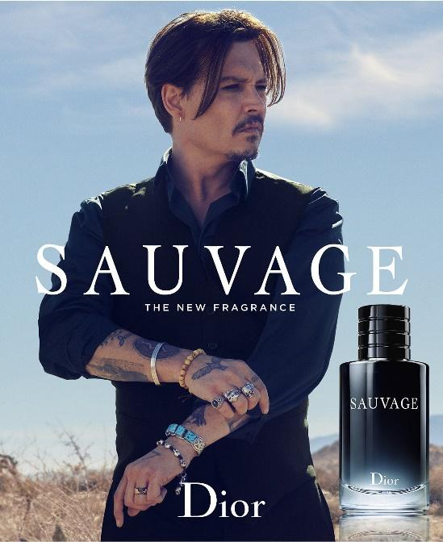

Write your short paragraph here about how you think representations of gender have changed. Explore other images online if you want further examples.
Week4:
Media Industries
When we look at Media industries in Media Studies we look at the ownership of media companies and how ownership affects the budget and production of different media texts.
We also look at the impact of digital technology and regulation on media texts

TASK 6: MEDIA INDUSTRY QUIZ!
See whether you know the answers to any of these questions already. If you don’t know the answer carry out a bit of research and find out what it is!

- Name two companies that Disney owns

- If a film is rated 12A who can go and see it?

- What 2 UK national newspapers does Rupert Murdoch’s company News Corps own?

- How do magazine publishers use digital media to make magazine content available online?

- What different channels does the BBC have?

- Who regulates TV and radio?

- What is a PEGI rating in relation to gaming?

- What different ways can a music artist release their songs?

- What does ASA stand for in relation to advertising?

- What company produces the James Bond films?

Media Audiences

We are all Media Audiences, we all consume media texts every day. As media students you will learn to understand WHY audiences consume different texts and HOW different media texts are constructed to appeal to specific audiences
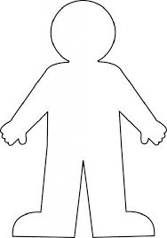
Task 7: Below are a collection of media texts and products and a person outline. Look at the types of texts and create a profile for the type of person who would interact with the texts by writing in the outline information like age, gender, interests, hobbies, and any other information or words that come to mind when you look at the media texts
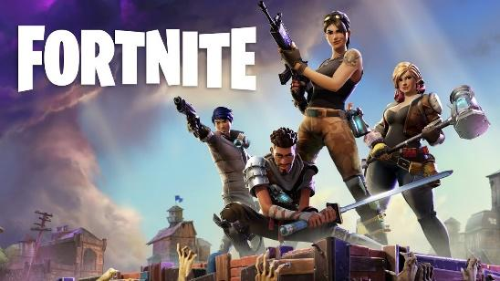
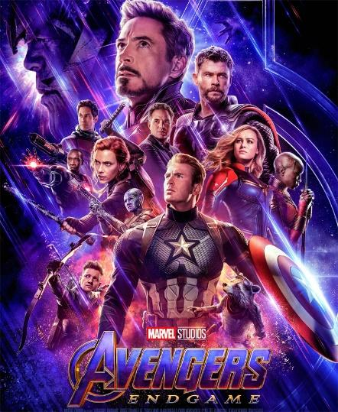
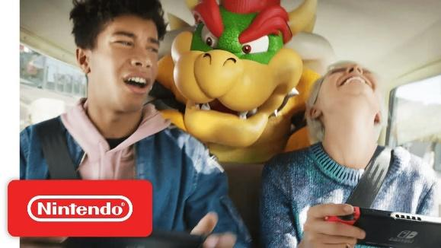

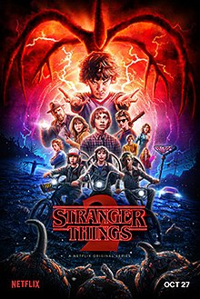
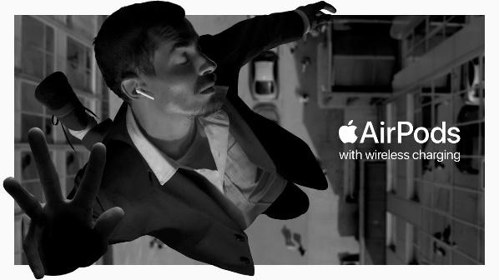

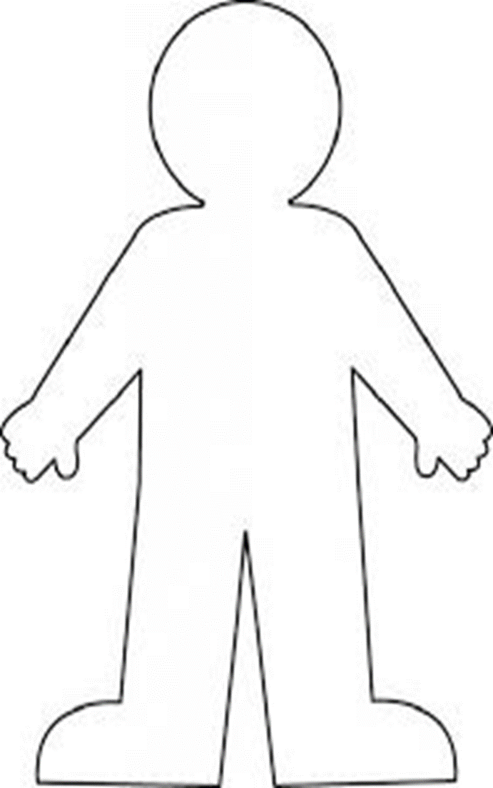

TASK 8: Now do it for yourself! You are also a media consumer. Create an audience profile for yourself based on the types of media texts that appeal to you. Think about all areas of the media when you are creating your personal profile.
Fill the person outline with words about yourself (age, interests, personality, etc..) and then surround it with words or pictures of media texts that appeal to you.

